Traceable Optical Metrology Software for Geometric Conformity Assessment of Complex 3D Parts
L. Fofana^{1,2,*}, K. Josic^{1,2}, L-F. Lafon^{1,2}, L. Teir³, L. Ribotta⁴, J. Guillory¹, R. Klobucar⁵, C. Mehdi-Souzani², S. Catalucci⁷, Z. Xiangchao⁸, O. Bruneau², B. Acko⁵, M. Galetto⁶, N. Anwer², R. Mayer⁹, B. Cheung¹⁰, H. Nouira¹
¹ LNE-CNAM (FR), ² LURPA / ENS Paris-Saclay (FR), ³ VTT MIKES (FI), ⁴ INRiM (IT), ⁵ Univerza v Mariboru (SL), ⁶ Politecnico di Torino (IT), ⁷ Università degli Studi di Padova (IT), ⁸ Fudan (CH), , ⁹ Polytechnique (CA) , ¹⁰ PolyU (HK)
* Ladji FOFANA: ladji.fofana@lne.fr

Keywords : Machine Vision Systems, Photogrammetry, Dense Image Matching, Metrological traceability, 3D reconstruction, Reference Artefacts, Form Deviation Analysis, Industry 4.0

Abstract
The increasing deployment of vision-based inspection systems in industrial environments requires the development of traceable measurement methods capable of ensuring dimensional conformity at the micrometer scale. This contribution presents a traceable photogrammetric workflow for 3D geometric verification of complex parts, developed within the framework of the European project: 23IND08 DI-Vision, aiming to develop traceable machine vision systems for digital industrial applications.
The proposed measurement workflow combines a high-resolution stereo camera pair with a dense reconstruction algorithm to build a non-contact equivalent of traditional tactile systems. Image information captured from multiple overlapped views is geometrically matched under constraints for global refinement using bundle adjustment. Dense point clouds are computed using multi-view triangulation and processed to enable accurate surface reconstruction and form deviation analysis.
Software validation, including 3D reconstruction accuracy and form deviation analysis, is performed using reference softgauges of representative automotive mechanical components and complies with ISO 5436-2 to ensure reproducibility and reliability, thereby maintaining traceability to the SI metre. Each processing stage and the associated uncertainty budget are defined according to metrological guidelines to reinforce traceability.
Based on real-world inspection applications, particularly in the automotive sector, the system enables real-time conformity verification by comparing reconstructed parts to CAD models, with a focus on identifying first-order form deviations. Its flexibility with respect to various geometric characteristics and surface finishes offers considerable advantages in terms of throughput and flexibility compared to contact systems, while maintaining the same level of traceability. This software addresses a major challenge in dimensional metrology by providing a validated and traceable optical measurement process. It enables the implementation of tight tolerances verification by photogrammetry in manufacturing settings, in accordance with the principles of Industry 4.0. It fills the traceability gap in optical systems and provides a solid basis for the metrological qualification of vision-based inspection process in production.

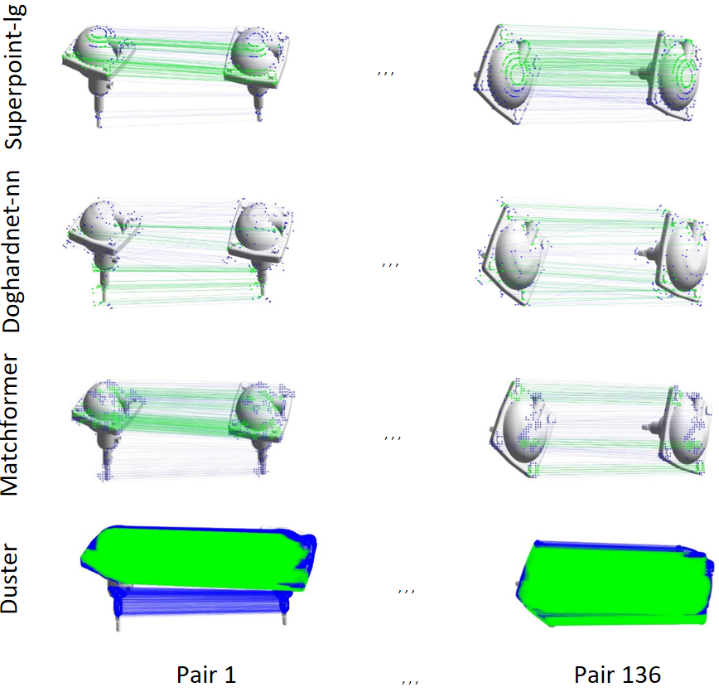

Figure 2: Feature Matching Comparison on Brake Caliper Image Pairs
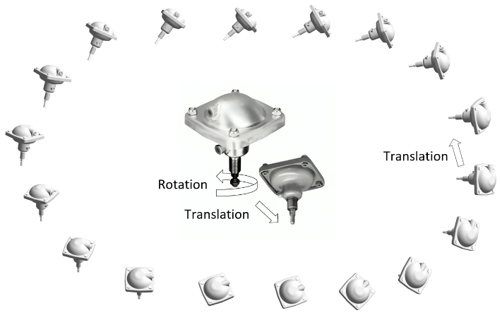

Figure 1: Pose Variation of a Brake Caliper for 3D Reconstruction

Acknowledgments
This research is part of the 23IND08 DI-Vision Project, dedicated to advancing traceable machine vision systems for digital industrial applications. We acknowledge the support and collaboration of the European Partnership on Metrology and its associated institutions, which played a pivotal role in enabling the development and validation of methodologies essential to this work.

