A quantum standard of resistance without magnetic field

Luca Callegaro ORCID: 0000-0001-5997-9960

Istituto Nazionale di Ricerca Metrologica
Strada delle Cacce 91, 10135 Torino, Italy
e-mail: l.callegaro@inrim.it

The universality of the quantum anomalous Hall effect in a magnetically-doped topological insulator has been demonstrated to an accuracy of a few parts in 10⁹ at zero magnetic field, paving the way towards a new type of quantum standard of resistance

Until 2019, the International System of Units (SI) defined the base unit ampere, and consequently all electrical units, in mechanical terms. Any realisation of the electrical units was an electromechanical experiment, where both electromagnetic and mechanical (geometry, force) quantities had to be measured to the best accuracy possible.

The 2019 revision of SI [1] gets rid of such electromechanical approach, and defines the electrical units indirectly, by assigning to the elementary charge e and the Planck constant h fixed values with no uncertainty. Any experiment that measures an electrical quantity in terms of e and h is a realisation of the corresponding unit of that quantity. The SI has thus became intrinsically quantum in nature.

Units of electrical resistance (the ohm) and impedance (henry, farad) can be realised in terms of the quantum of resistance, also called the von Klitzing constant R_{K} = h/e² = 25812… Ω. National Metrology Institutes worldwide exploit for the realisation the quantum Hall effect (QHE) in semiconductor devices. The experimental conditions required are temperatures around 1 K and magnetic fields of 10 T, achieved in cryostats equipped with superconducting magnets weighing hundreds of kg. More recent graphene devices allow to relax such conditions to temperatures of a few K and magnetic fields of 3-6 T [2].
The need of QHE for a magnetic field of high intensity is a major limitation for the integration of other quantum devices in the same cryogenic environment. Josephson junction devices, in particular, must operate at negligible magnetic fields. Shielding techniques are possible but increase the size and complexity of the cryostat.

Among Josephson devices of particular relevance for electrical metrology there is the Josephson voltage standard, which exploit another combination of the same fundamental constants h and e (the flux quantum Φ₀ = h/(2e) = 2.067833848 ...×10⁻¹⁵ V s) for the realisation of the unit of electric voltage, the volt V. Another device highly relevant for electrical metrology is the SQUID, Superconducting Quantum Interference Device, which provides ultimate detection sensitivity of electromagnetic quantities and is the basis of the Cryogenic Current Comparator (CCC), see later in this note. More recent experiments towards the realisation of the unit of electric current, the ampere A, quantum phase slip devices [3], are also based also employ Josephson junction devices.
The discovery of Quantum Anomalous Hall Effect (QAHE) in magnetically-doped topological insulator (TI) devices is a recent breakthrough [4]. Such devices, see Fig. 1, have an intrinsic magnetization and display the quantum of resistance also at zero applied magnetic field. They are therefore candidates for integrating the quantum standard of resistance with the Josephson voltage standard and other Josephson devices. Combinations of voltage and resistance allow the creation of standards for the other electrical quantities, including electric current, charge, power and energy.

The most important property of a physical phenomenon to be a basis for the realisation of a unit is its universality. The universality of QHE, that is the exactness of the displayed quantized resistance value and its independence of the device material, fabrication and—within the operating limits—working temperature, magnetic field and measurement current, has been extensively investigated both theoretically and experimentally [5].

QAHE is a much recent discovery. The underlying physics is not yet fully developed, and the best material candidates not yet identified; the fabrication of devices is in its infancy. Present devices show strong limitations in the maximum operating temperature (below 1 K) and measurement current (below 1 μA) which are not well understood. The actual universality of QAHE is an open question.

The paper “Zero External Magnetic Field Quantum Standard of Resistance at the 10⁻⁹ Level” [6] is a major breakthrough to establish the universality of QAHE. As the title suggests, the equivalence of the resistance displayed by QAHE at zero magnetic field and the quantum of resistance is assessed with an accuracy of a few parts in 10⁹, the same level of accuracy of typical QHE experiments in NMIs.

The experiment is a real tour de force in electrical metrology. The QAHE device is probed at the base temperature of 34 mK in a dilution refrigerator. After an initial characterisation, where the hysteresis loop of Fig. 1 is measured and a proper gate voltage bias established, the resistance is measured by comparison with a 100 Ω standard resistor, which value is known in terms of the QHE. The comparison is performed with a Cryogenic Current Comparator (CCC) resistance bridge, hosted in another cryostat, which measure a resistance ratio by comparing the resistors’ currents in a superconducting dc ratio transformer, using a SQUID as detector. To stay within quantization limits, the applied current must be in the order of 100 nA. The special CCC employed, having a large number of turns, can achieve the necessary sensitivity and accuracy—to the femtoampere level.

The paper elevates QAHE to the level of a quantum standard directly suitable for the realisation of the unit of resistance, and suitable for direct integration with other quantum devices.

New QAHE devices will be realized in the near future, which will hopefully overcome the limitations in temperature and operating current of the present ones. The paper, with its rigorous approach, constitute an essential reference that the forthcoming metrology experiments on QAHE will have to match.

Acknowledgment

The author acknowledges the project 23FUN07 QuAHMET, which has received funding from the European Partnership on Metrology, co-financed from the European Union’s Horizon Europe Research and Innovation Programme and by the Participating States.

References

[1] Bureau International des Poids et Mesures, “The International System of Units,” May 20 2019, 9th SI Brochure. [Online]. Available: www.bipm.org

[2] T. J. B. M. Janssen, A. Tzalenchuk, S. Lara-Avila, S. Kubatkin, V. I. Fal'ko, “Quantum resistance metrology using graphene”, Rep. Prog. Phys. 76, n. 10, p. 104501, DoI: 10.1088/0034-4885/76/10/104501

[3] N. Crescini, S. Cailleaux, W. Guichard, C. Naud, O. Buisson, K. W. Murch, N. Roch. “Evidence of dual Shapiro steps in a Josephson junction array,” Nat. Phys. 19, 851–856 (2023). https://doi.org/10.1038/s41567-023-01961-4

[4] C.-Z. Chang, J. Zhang, X. Feng, J. Shen, Z. Zhang, M. Guo, K. Li, Y. Ou, P. Wei, L.-L. Wang, Z.-Q Ji, Y. Feng, S. Ji, X. Chen, J. Jia, X. Dai, Z. Fang, S.-C Zhang, K. He , Y. Wang , L. Lu, X.-C. Ma, Q.-K. Xue, “Experimental Observation of the Quantum Anomalous Hall Effect in a Magnetic Topological Insulator,” Science 340, 167-170 (2013). DoI:10.1126/science.1234414

[5] Poirier, W., Schopfer, F. Resistance metrology based on the quantum Hall effect. Eur. Phys. J. Spec. Top. 172, 207–245 (2009). https://doi.org/10.1140/epjst/e2009-01051-5

[6] D. K. Patel, K. M. Fijalkowski, M. Kruskopf, N. Liu, M. Götz, E. Pesel, M. Jaime, M. Klement, S. Schreyeck, K. Brunner, C. Gould, L. W. Molenkamp, H. Scherer, “Zero external magnetic field quantum standard of resistance at the 10⁻⁹ Level”, Nat. Electron., (in press)

Figure

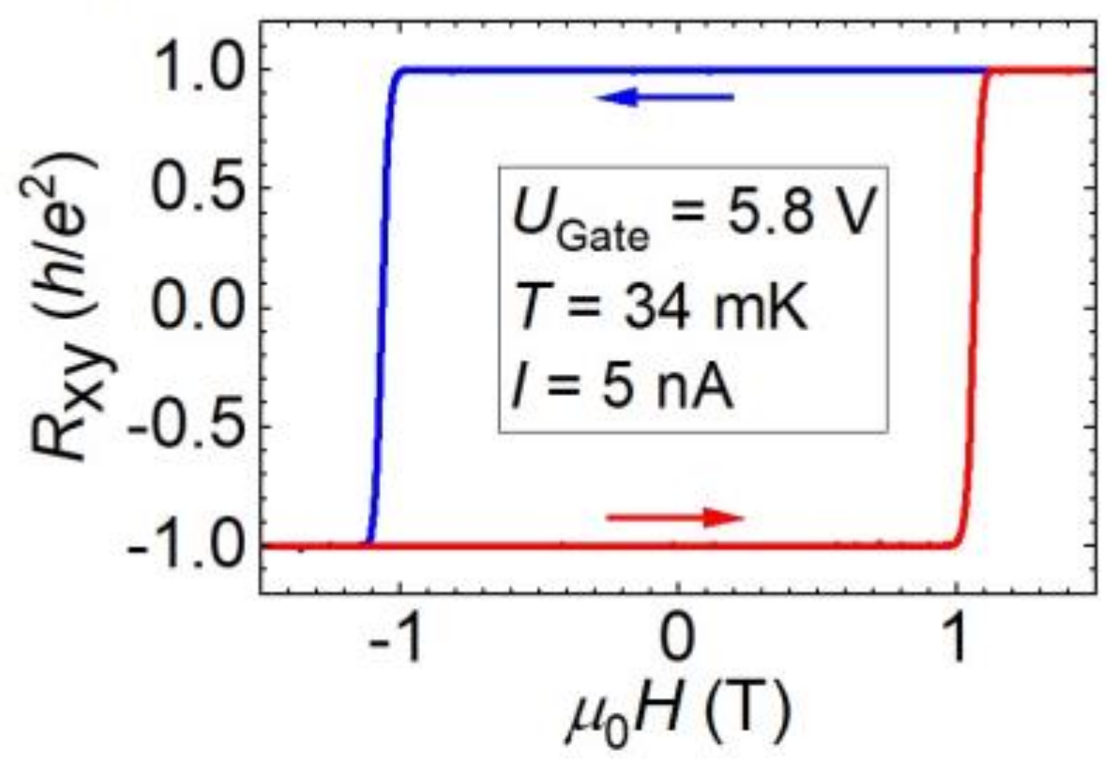

Fig. 1. The hysteretical behaviour of the Hall resistance R_{xy}, in units of the quantum of resistance h/e², versus the applied magnetic field induction μ₀H. The device is a magnetic-doped topological insulator (9 nm-thick V_{0.1}(Bi_{0.2}Sb_{0.8})_{1.9}Te3) Hall bar device, provided with two current contacts, 6 voltage contacts, and an electrostatic gate for carrier concentration tuning. See details in Ref. [6], from which the figure is taken.

