Ultrafast laser direct writing nanogratings and their engineering in transparent materials

Heng Yao^{1,2}, Diego Pugliese^{3,4}, Matthieu Lancry^{2,*} and Ye Dai^{1,*}

¹Department of Physics, Institute for Quantum Science and Technology, Shanghai University, 200444 Shanghai, China
²Institut de Chimie Moléculaire et des Matériaux d’Orsay, CNRS, Université Paris-Saclay, 91400 Orsay, France
³Department of Applied Science and Technology (DISAT) and RU INSTM, Politecnico di Torino, 10129 Torino, Italy
⁴National Institute of Metrological Research (INRiM), 10135 Torino, Italy
E-mails: matthieu.lancry@universite-paris-saclay.fr; yedai@shu.edu.cn

Keywords: nonlinear light-matter interaction, ultrafast laser, nanogratings, optical chirality, optical applications

Femtosecond laser direct writing is a powerful technique for fabricating micro-nano devices as it can modify the interior of transparent optical materials in a spatially selective manner through nonlinear multi-photon absorption. In this context, laser-induced nanogratings, i.e. a sub-wavelength assembly of nanolayers (~20 nm in width, ~200 nm period), are ultrashort self-organized structures created by light in the bulk of transparent materials. These have been intensively explored over the last two decades opening a novel era of micro photonic devices due to their unique physicochemical properties, like orientable form birefringence, anisotropic light scattering, highly selective chemical etching, optical chirality, and extraordinary thermal stability. This review provides a throughout overview of the advances in this field, specifically focused on the formation of nanogratings, optical properties that can be exploited in various transparent solids and the related main applications. Also, the fundamental characteristics, formation mechanism, tuning methods of nanogratings are reviewed.

1. Introduction

Femtosecond (fs) laser direct writing (FLDW) is a multifunctional tool enabling permanent modifications of physical and chemical properties inside transparent solids, like glass, crystal and polymer.^{[1-9]} Also, two-photon polymerization (TPP), belonging to additive manufacturing, i.e., three-dimensional (3D) printing, is an important manufacturing method to achieve many complex structures towards advanced photonic applications.^{[10,11]} No other techniques can be utilized for realizing 3D multi-functional photonic devices in one-single step within multifarious transparent materials. FLDW is achieved by tightly focusing a fs-laser beam on or below the surface of transparent substrates, and in this case the tightly focused beam can reach several TW/cm², which yields to the strong nonlinear absorption and permanent modifications of the raw materials within few µm³ in and around the laser focal volume. Davis et al.^{[12]} have firstly presented the 3D laser processing using a regeneratively amplified 810 nm Ti-sapphire laser with pulse duration of 120 fs. They suggested that low photon energy at visible (Vis) and infrared (IR) wavelengths could induce multiphoton photochemical modifications, e.g., optical waveguides in glass. Therefore, ultrashort pulse duration and nonlinear interaction provided 3D bulk confinement.
Permanent glass modifications induced by fs-laser pulses can be classified into three types, i.e., commonly referred to as Type I, Type II and Type III in the literature.^{[12-14]} Type I modifications are observed at low pulse energies and are characterized by a smooth and homogenous structural modification (e.g., permanent and isotropic refractive index shift) beyond a critical threshold^{[15]} which is suitable for the manufacturing of low loss optical waveguides or lens. Defect centers, like color centers, created by fs-laser irradiation can be one of the sources leading to the refractive index change by the Kramers-Kronig relationship (the change of absorption leads to the refractive index change).^{[16]} In addition, it has been reported that color centers contribute to the refractive index changes for nearly 20% in SiO₂ glass for the realization of waveguides, and the primary part is attributed to the defect-assisted densification by the authors.^{[17]} Lancry et al.^{[3]} proposed a model based on an original physico-chemical mechanism for the explanation of Type I modification. They suggested the threshold of Type I modification is based on the fictive temperature T_{f} of transparent glass, while the heating time of pulse is higher than the relaxation time of glass, η(T)/G(T), where η and G are the viscosity and the shear modulus of the glass, respectively. Interestingly, chemical composition fluctuation has little impact on the Type I formation threshold.^{[3]} Moreover, for slightly higher deposited energies, Type II modifications are generally observed presenting totally different origin and structures from Type I modifications. Type II modifications are first distinguished by an anisotropic change in the refractive index and anisotropic light scattering. Under specific laser conditions, a strong form birefringence appears with an outstanding thermal stability, which originates from periodic lamellar nanostructures oriented perpendicularly to the laser polarization,^{[18]} as shown in Figure 1. These optical modifications are associated with the formation of nanogratings (NGs), i.e., a subwavelength assembly of nanoporous layers. Fs-laser-induced NGs find extensive applications in several technological fields. They play a central role in the creation of long-term optical data storage devices,^{[19,20]} optical sensors,^{[21,22]} and microfluidics devices.^{[23,24]} Importantly, they are also employed in the fabrication of various optical elements, including optical waveguides, polarization converters,^{[25,26]} and other 3D space variant birefringent elements^{[27]} or 3D geometric phase optics.^{[28]} Despite the broad scope of their applications, a comprehensive understanding of the mechanisms behind NGs formation in glass remains to be achieved. This is crucial, as it impacts their fabrication and, consequently, the optimization of their use in various technological contexts. Finally, ultrafast laser induced voids (a few hundreds of nm, named as Type III modifications, potentially of interest for optical data storage) are created inside the laser-irradiated volume when the light intensity exceeds ≈10¹⁴ W/cm² in silica.^{[14]} Voids are supposed to be issued from a mechanism called micro-explosion. Micro-explosion, also called as soft Coulombian explosion, was first suggested by Fleischer et al.^{[29]} in 1965 and is commonly considered as a part of high-intensity photo-ionization of materials. This has been, as well, reported elsewhere.^{[29,30]} The micro-explosion mechanism^{[30]} can be briefly explained as the process for refined rationalization: with the energy deposited in focal volume, an expansion pressure is very quickly produced which later motivates a shock wave and stress exceeding the Young’s modulus of the bulk materials. The generated spherical shock wave begins to propagate outside the center of symmetrical energy-deposited spot, compressing the bulk solids.^{[14,31-34]} Besides, Poumellec et al. have proposed an overview of these types of structural modifications.^{[15]} Alternatively, another modification, called “heat accumulation” (Type I-like structure), available in fs-laser systems operated in high repetition frequency or high pulse energy, is generally defined in the literature.^{[35]} It corresponds to the case where the pulse interval approaches or becomes shorter than the heat diffusion time required to totally evacuate the deposited heat after the pulse. Following the quantitative view, the diffusion time τ_{D} (the deposited energy to be dissipated out of the focal volume) could be expressed by τ_{D} = $ω_{0}^{2}$/2D, where ω₀ is the focal radius and D is the diffusivity of the materials.^{[36]} The diffusivity, D, is defined as: $D = κ/ρ∙C_{p}$, with κ the thermal conductivity and C_{p} the specific heat, and ρ the density of material. Typically, the size of a single pulse modification is nearly 1 μm in SiO₂ glass using a numerical aperture (NA) of 0.5, subsequently resulting in a diffusion time of nearly 2 μs. If pulse interval is much shorter than heat diffusion time, typ. 1/f<7τ_{D},^{[37]} the temperature of laser focal volume will increase in multi-pulse irradiation regime. Therefore, high-repetition-rate fs-laser generally leads to localized melting of bulk glasses due to the heat accumulation effect. Heat accumulation, during fs-laser irradiation of bulk glasses, was first demonstrated by Schaffer et al.^{[38]} They indicated that the modification size increased with the laser pulse number within zinc-doped borosilicate glass (Corning 0211) under a very high-repetition-rate (25 MHz) fs-laser irradiation. The authors explained this modification trend by heat accumulation of high repetition laser and predicted the modification size using a thermal diffusion model.^{[38]} Moreover, Eaton et al.^{[39]} investigated the modification volume from the simulated temperature increase due to heat accumulation at different repetition rates (0.1 - 5 MHz) and revealed heat accumulation marked in alkali-free borosilicate glass over 200 kHz where pulse interval is shorter than the time of heat diffusion out of the focal region. Interestingly, Dai et al.^{[40]} induced Fresnoite (Ba₂TiSi₂O₂) crystal inside BaO-TiO₂-SiO₂ glass, due to the thermal accumulation of high-repetition-rate laser which favors crystal growth. Fresnoite crystal is anisotropic and shows the strong optical frequency doubling, which is thus suitable for the applications, like 3D full-color display. Even though many studies have been performed upon these laser-induced modifications, the complete control of modifications is still facing several challenges. Therefore, far more experiments need to be conducted and the mechanisms of laser-induced modifications need to be further investigated.
In this review paper, after a quick introduction on “surface NGs” usually called laser induced periodic surface structures (LIPPS), we firstly present the discovery of bulk NGs and their key inner nanostructure characteristics (see section 2.2) for understanding the origin of their exciting optical properties. Then, we discuss the unique properties of NGs, like form birefringence origin, polarization dependent anisotropy, extraordinary thermal stability, optical chirality or erasing/rewriting capability (see section 2.3), which can be exploited for a wide range of optical applications. Further, to control and tune the formation process of NGs and related properties, the laser parameter dependencies (energy, pulse duration, pulse number, repetition rate, double pulse etc.) of NGs formation are extensively described including chemical composition effects (see section 2.4). Moreover, the relevant models of NGs formation, from plasmon-photon interference to self-trapped excitons (STEs) (see section 2.5), are then presented and discussed. This provides a quite large and quantitative overview upon NGs formation. Finally, in section 2.6 we present the main NGs-based integrated optical applications (e.g. ultra-stable 5D optical data storage or micro-optical elements) opening the innovative era of optics and photonics.

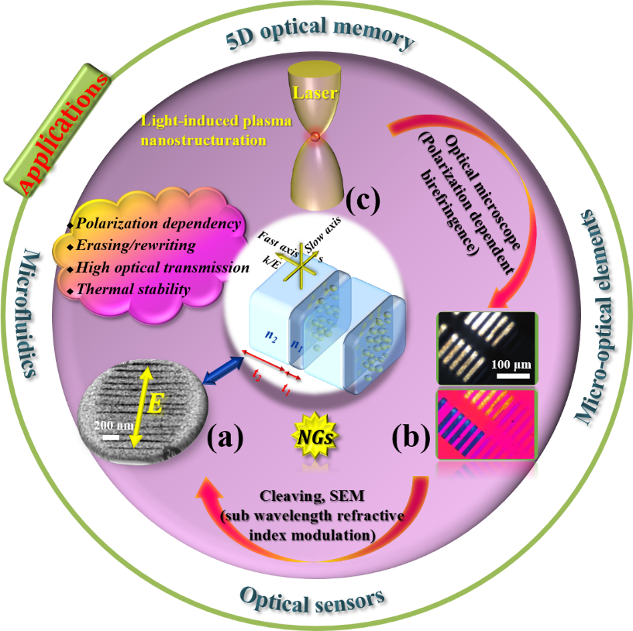
Figure 1. Outline of laser-induced NGs, including sketch of NG structures (at the center), the characterization methods, unique properties and main targeted applications in the surrounding circle. (a) Typical scanning electron microscopy image of NGs, dark lines represent nanoplanes, E is laser polarization. Reproduced with permission from ref.^{[13]} Copyright 2003, The American Physical Society. (b) Polarized optical microscope image with crossed polarizers (up photo) and a full waveplate (down photo). Reproduced with permission from ref.^{[41]} Copyright 2022, Elsevier. (c) Sketch of anisotropic ionization caused by ultrafast laser in focal volume.

2. Femtosecond laser induced Type II modifications (so-called NGs)

2.1. From LIPSS to self-organized NGs in silica
LIPSS represent a universal phenomenon and can be generated on virtually any type of media including metals, semiconductors and dielectrics upon irradiation with linearly polarized light.^{[42-45]} The ripples can be formed with wavelengths ranging from the mid-infrared to the blue end of the visible spectrum and at pulse durations from continuous wave operation to fs laser systems.^{[46,47]} For normal incidence, the period of surface structures was known to be close to the wavelength of the light and oriented perpendicularly to the laser beam polarization.^{[48]} For oblique incidence and transverse magnetic (TM) polarization (electric field is oriented parallel to the plane of incidence) the ripples occur with one of two possible periods:^{[44]}
$Λ=\frac{λ}{1±\sin{θ}}$ (1)
where 𝜃 is the angle of incidence of laser beam, as shown in Figure 2b, and the negative or positive signs correspond to the forward and backward scattering, respectively. One interesting prospect from an application viewpoint is that when laser beam is moved with respect to the sample, the ripples can coherently extend over the scanned area.
Lately, ultrashort laser pulses were observed to induce two types of periodic surface structures depending on the period of the structure:^{[49]} above single pulse damage threshold – ripples with a period close to the wavelength (~𝜆), and below single pulse damage threshold – subwavelength ripples with periods down to 30 nm (𝜆/10).^{[43,50]} Here, the period was found to be dependent on the number of pulses and the subsequent carrier density,^{[43,51,52]} where the final subwavelength structure is formed only after tens or even thousands of pulses.
In general, the understanding of the formation mechanism of LIPSS is a challenging task as it involves a complex sequence of inter- and intra-pulse physical processes as reviewed in the literature.^{[53,54]} It is generally accepted that low-spatial frequency LIPSS (LSFL) are generated by the interference of the incident laser beam with an electromagnetic wave scattered at the rough structure and may involve the excitation of surface plasmon-polaritons (SPPs), particularly important when irradiating with fs laser pulses.^{[47,52,55,56]} The surface wave driven periodic modulation of the electromagnetic field along the laser polarization gives anisotropy in the following modification processes. It is assumed that the further steps are governed by the fast (non-thermal) and slow (thermal) phase transitions.^{[57]} Interestingly, the early-stage ripples upon a subsequent pulse irradiation modulate the light-matter interaction and reduce the periodicity of the pattern.
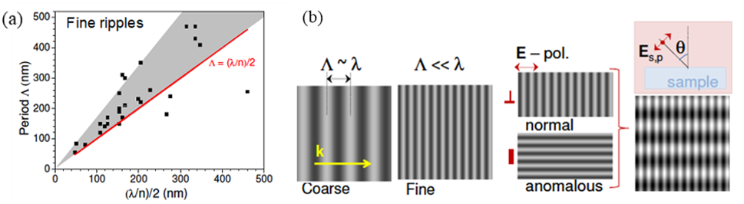
Figure 2. (a) Fine ripples period Λ dependence on the laser wavelength λ and on the material refractive index n. The gray-shaded region marks an expected (0.5 − 0.85)·λ span of Λ values for the absorbing (plasma) surfaces according to the SPP surface plasma wave mechanism. (b) Ripples of period Λ on surfaces irradiated with wavelength λ laser pulses at an incidence angle θ = 0° (normal incidence): coarse, fine, normal (⊥), anomalous and mixture, which occurs at θ > 0°. Figure reproduced with permission from ref.^{[54]} Copyright 2014, Elsevier.

In contrast, the high-spatial frequency LIPSS (HSFL) exhibit the following features: (i) are formed at fluencies very close to the damage threshold of the irradiated material; (ii) have spatial periods significantly smaller than the irradiation wavelength; (iii) are usually observed for irradiation with ultrashort laser pulses (iv) mostly for excitation of transparent materials with a photon energy below the bandgap and (v) hundreds to thousands of laser pulses per irradiation spot. Within the interpretations proposed in previous studies, the early-stage laser induced unstable nanostructures, during the relaxation of a highly non-equilibrium surface, tend to self-organize into HSFL patterns. However, the origin of the HSFL is still under debate.^{[53,54]}

2.2. Discovery and structural characteristics of NGs

In 1999, Sudrie et al.^{[58]} have firstly observed linear birefringence (typ. 1 rad) in bulk fused silica under the fs-laser irradiation. Both transmission phase gratings with polarization dependence and birefringent sheets have been conducted, as shown in Figure 3a and b, leading to polarization sensitive components including quarter-waveplates applied in beam splitters or polarization accessible optical memories. Meanwhile, Kazansky et al.^{[59]} revealed that blue luminescence spot is elongated along the pump polarization under fs-laser irradiation, as illustrated in Figure 3c-f, which has predicted the presence of NGs. Qiu et al.^{[60]} further speculated on the existence of NGs induced by fs-laser in Eu²⁺-doped fluoroaluminate glass in 2000. Afterward, in 2003, Shimotsuma et al.^{[13]} firstly revealed self-organized periodic nanostructures inside silica glass inscribed by fs-laser and demonstrated that nanolayers are always perpendicular to the laser polarization, as in Figure 3g-j. Backscattering electron images (Figure 3h and j) revealed the nanolayers of stripe-like region of ~20 nm width along with a low oxygen concentration in the focal spot irradiated by fs-laser. Furthermore, by using Auger photoemission, the authors revealed that the dark region in focal spot irradiated by fs-laser exhibited low density, i.e., understoichiometric silica (SiO_{2-x}). In contrast, the bright region presented oxygen-richness and higher refractive index.

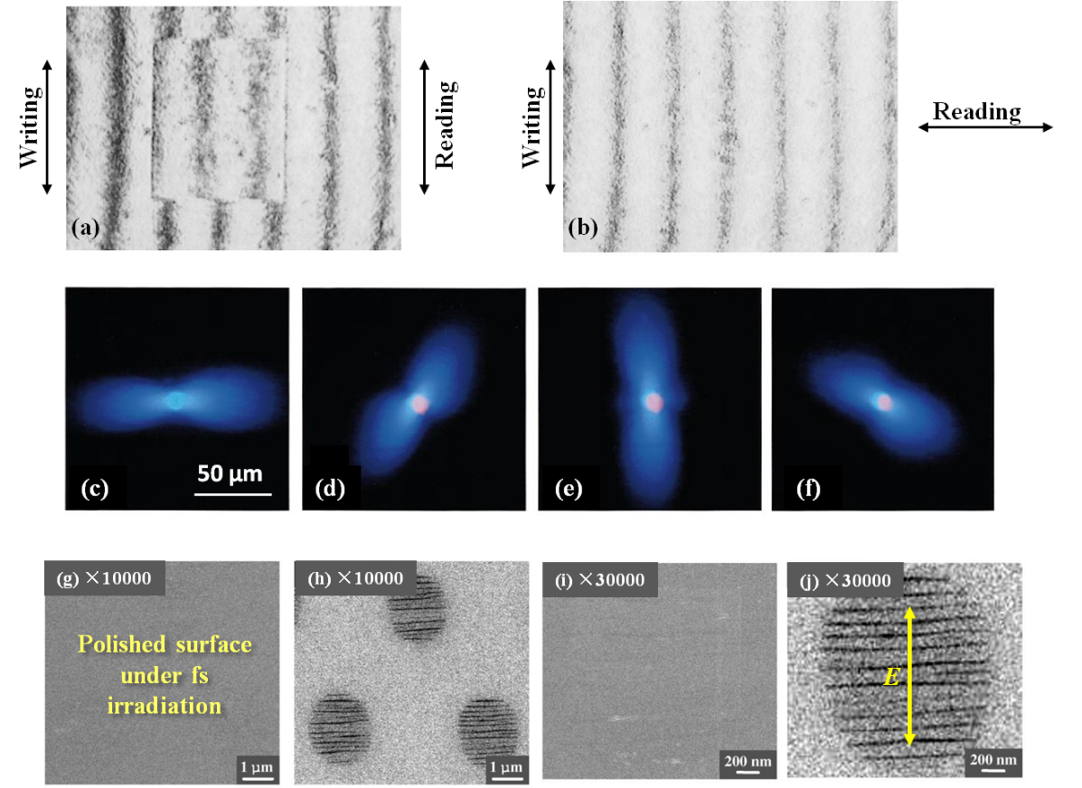
Figure 3. Michelson interferogram of a platelet presenting an induced birefringent microlayer along with the dimensions of 5 × 4 mm². (a) and (b) are with Xx configuration and Xy configuration, respectively, where the first (second) letter designates the polarization direction of the writing (reading) beam. Reproduced with permission from ref.^{[58]} Copyright 1999, Elsevier. Photographs of the blue luminescence spots in the focus of the linearly polarized pump with four different orientations of polarization [(c)-(f)]. The blue luminescence point is elongated along the pump polarization. Reproduced with permission from ref.^{[59]} Copyright 1999, The American Physical Society. (g), (i) Secondary electron graphs of silica glass in the focal spot. (h), (j) Backscattering electron graphs of the same position in silica glass, E presents the polarization. Reproduced with permission from ref.^{[13]} Copyright 2003, The American Physical Society.

Indeed, a number of very unique features including selective chemical etching, micro/nano-shearings, lower density nanoporous layers were observed upon NGs. In 2006, Hnatovsky et al.^{[24]} have revealed that nanolayers were highly sensitive to hydrofluoric (HF) acid etching by using scanning electron microscopy (SEM), as shown in Figure 4a and b. They presented that the polarization-dependent self-assembly periodic nanostructures or nanoporous structures determined the etching rate inside the laser-modified areas. In addition, they found the maximum lengths of narrow microchannels were limited to the range of 1 to 2 mm for the etching proceeding from one end. The optimum laser irradiation conditions were further presented in this study to obtain high-aspect ratio microchannel structures. Also, they demonstrated that the solutions to improve the aspect ratios contained: 1) perfect alignment of the nanolayers with the scanning orientation; 2) the optimization of the etchant; 3) raster scan of the laser beam to reduce the tapering effect; 4) elimination of the cracks or disruptions by changing laser parameters for promoting the acid flow. In parallel, Drevinskas et al.^{[61]} have also presented the polarization-dependent linearly increased optical retardance reaching a threefold value within 25 hours by potassium hydroxide (KOH) etching at room temperature due to the feature of easier selective etching in the fs-laser modified, defects-rich regions. Moreover, in 2008, Taylor et al.^{[62]} have revealed that the SEM image at longer pulse duration, $τ$_{p} = 300 fs, showed more disruptive with a modulated fracturing with variable thickness of 5-30 nm compared to that of $τ$_{p} < 185 fs with narrow, straight and uniform cracks, and crack thickness of 5 nm was limited by the SEM resolution, as in Figure 4c-e. They suggested that the formation of nanocracks might be from the cleaving process.

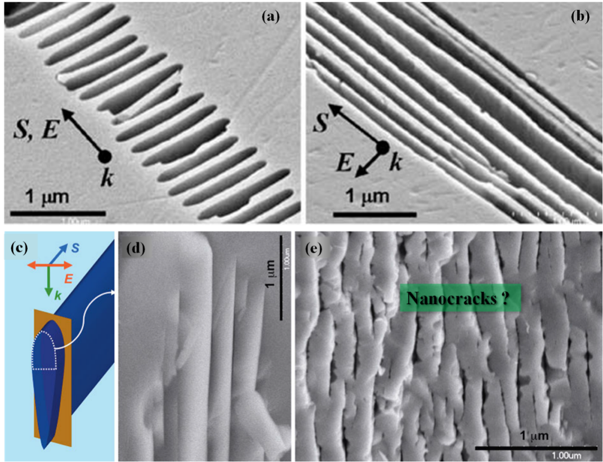
Figure 4. Polarization-selective etching enabled by the NGs formation. SEM images of XY-sections of laser-induced modification of fused silica in the focal region with laser polarization (a) parallel and (b) perpendicular to the writing direction. The polished samples were etched for 20 min in 0.5% HF. Nanocracks nature of the NG structures. Reproduced with permission from ref.^{[24]} Copyright 2006, Springer-Verlag. YZ-plane of cleaved surfaces shown in panel (c). E is perpendicular to S and K. SEM images in (d) and (e) correspond to a short pulse duration of 50 fs and to a longer one of 300 fs, respectively. Reproduced with permission from ref.^{[62]} Copyright 2008, John Wiley and Sons.

On the other hand, Poumellec et al.^{[63]} in 2003, firstly found that a shear stress occurred while the pulse energy was larger than 0.1 µJ using phase shift interferometry. Furthermore, another shear stress, corresponding to the laser scanning direction and the coupling with phase matching condition between the pump wave and the third harmonic, appeared while the pulse energy was higher than 0.25 µJ. Here, the controlling of asymmetric printing in center-symmetric medium was presented, as shown in Figure 5a. In 2013, Lancry et al.^{[30]} revealed the nanostructure of the laser tracks using atomic force microscope (AFM) measurements in tapping mode, as in Figure 5b and c, and a series of dashes on images for discontinuities which presented multiple shearings with the same sign, were highlighted. They suspected that the nano-shearings were the cause of these nanostructures. Indeed, as early as in 2008, Bellouard et al. indicated that thermal conductivity decreased under fs-laser irradiation but with no regular cracks by using AFM and scanning thermal microscope (SThM),^{[64]} as in Figure 5d. In this case it is impossible to absolutely summarize the reason of the crack formations, such as the results of laser exposure, the cutting of specimen in fs-laser focal region or the defects (alike oxygen deficiency centers [ODC (II)] which will weaken the network structure of transparent solids). These are the strong evidences for the existence of stress-strain field in the vicinity of laser-modified region.
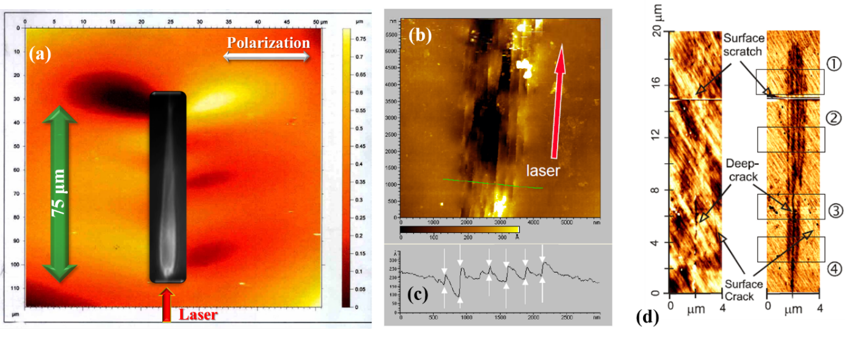
Figure 5. (a) Characteristic surface topography in nm of laser-induced modification in cleaved face of sample obtained by phase shift interferometer microscope with an objective X40. Polarization perpendicular to the laser scanning direction. Size of laser-induced modification (inset photo) along the laser propagation direction (red arrow) is 75 µm. Reproduced with permission from ref.^{[63]} Copyright 2003, Optical Society of America. A trace observed in AFM after cleaving: (b) close-up magnification of the head and (c) the profile along the green line as in (b). The distance between nanoplanes is roughly 300 nm. Polarization is perpendicular to the scanning direction. Reproduced with permission from ref.^{[30]} Copyright 2013, John Wiley and Sons. (d) SThM analysis of a high energy pattern (7.5 J/cm²) acquired with a transverse polarization. Topography and corresponding scanning contrast measurement. Oblique regular striation results from the polishing. Reproduced with permission from ref.^{[64]} Copyright 2008, Optical Society of America.

In 2011, Canning et al.^{[65]} have cleaved a nanolayer inside silica glass with no polishing, no etching, no conductive coating. The field-emission gun scanning electron microscopy (FEG-SEM) was performed and evidenced the presence of a high degree of porosity (dissolved molecular oxygen or interstitial oxygen atoms), as illustrated in Figure 6a. In general, these nanopores possessed typical diameter region from 10 to 30 nm and nanopore formation was initially considered to be the result of oxygen “expulsion” during silica glass decomposition. In 2013, Lancry et al. have calculated the temperature-time profile for absorbed energy densities related to the energy threshold of the nanoplanes formation.^{[30]} They firstly revealed that the matter within the nanoplanes is porous silica, as shown in Figure 6b and not silicon initially. However, silicon formation at the nanopores interface was later shown to happen as Raman spectra do show a peak at 518 cm⁻¹ specific of silicon-silicon vibration mode.^{[66]}
Additionally, the decomposition of SiO₂ into SiO_{2(1-x)} + xO₂ took less than a microsecond, that is longer than the time interval between two continuous pulses. Then the Raman spectrum was measured both in the pristine silica and the NG region, irradiated with various pulse energies from 0.13 µJ up to 1.10 µJ, as in Figure 6c. D₁ (495 cm⁻¹) and D₂ (605 cm⁻¹),^{[67]} as in Figure 6d, presented the breathing modes confirming a more important densification due to the generation of lower size, more compacted member rings (bridging oxygens in 4-membered and 3-membered rings, respectively) whilst wave packets at 770, 1050 and 1180 cm⁻¹ exhibited the stretching modes of Si-O-Si network. A low wave packet was observed at approximately 1550 cm⁻¹ indicating the existence of O₂ (i.e., dissolved oxygen within silica network at 1549 cm⁻¹,^{[68]} free oxygen at 1556 cm⁻¹,^{[69]} as in Figure 6c). Therefore, the increase of D₁ and D₂ was due to densified region at the vicinity of nanopores. It is caused by the strong compressive stress as a result of large expansion within nanolayers.^{[70,71]} Surprisingly, Zimmermann et al.^{[67]} have conducted the O₂ cartography along the laser track cross-section indicating that O₂ was concentrated in the head of laser track, where NGs were revealed. Besides, back to 2012, Richter et al.^{[72]} have in turn indicated that hollow cavities (typ. 30 $×$ 200 $×$ 300 nm³) were the primary constituents of NGs using small angle X-ray scattering (SAXS). Recently, in 2024 sheet-like nanocavities assembly were further confirmed using high resolution transmission electron microscope (HR-TEM) giving rise to substantial evidence of “light forced aligned” oblate-shape nanopores initially created through a plasma-mediated nanocavitation process.^{[73]}

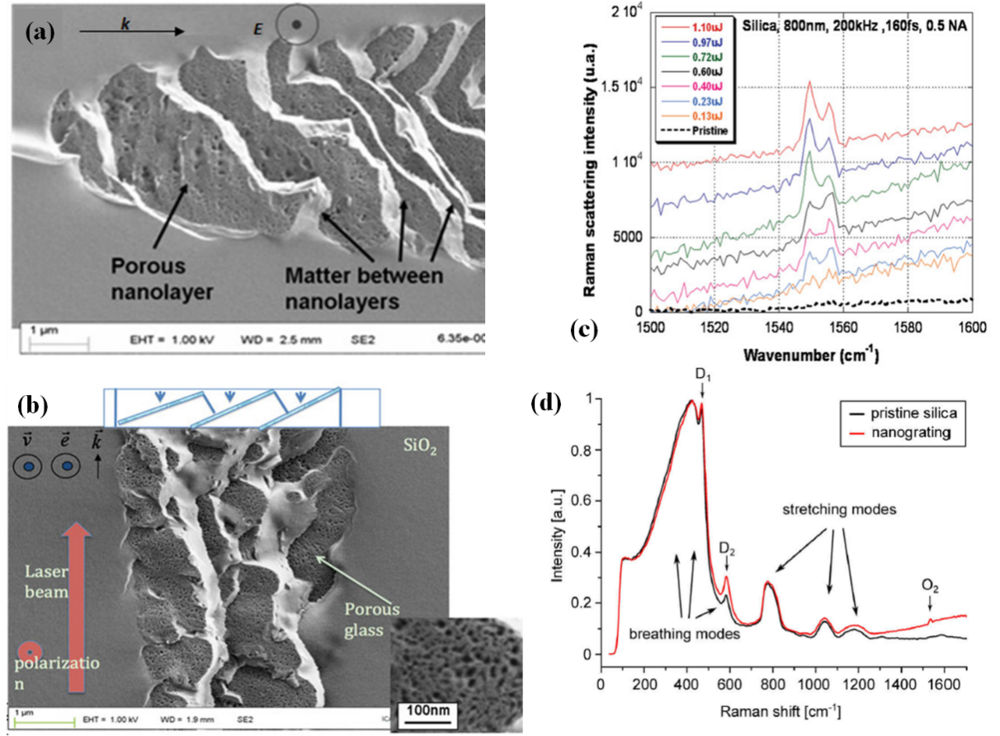
Figure 6. FEG-SEM secondary electrons images of laser tracks cross-section for each writing laser polarization. (a) The laser polarization was parallel to the scanning direction. Reproduced with permission from ref.^{[65]} Copyright 2011, Optical Society of America. (b) Laser tracks cross-section including the close-ups of the porous regions. (c) Raman scattering spectra of laser tracks cross-section according to pulse energy from 0.13 up to 1.10 µJ. Reproduced with permission from ref.^{[30]} Copyright 2013, John Wiley and Sons. (d) Raman spectra of the pristine glass section and the NGs section. The Raman scattering polarization was not analyzed. Reproduced with permission from ref.^{[67]} Copyright 2013, PhD Thesis.

2.3. Properties of femtosecond laser induced NGs

Actually, the laser-induced NGs (generally with 200-400 nm periodicity and persisting on mm range containing fringes as thin as 10-30 nm) were the ultrashort structures created by light.^{[13]} Since the first observation of NGs, they presented various features including multi-parameters dependence, birefringence as large as 10⁻²,^{[30]} retardance up to 2000 nm,^{[74]} dependency of slow axis orientation, high damage threshold (> 23 J/cm² @1064 nm),^{[75]} high scattering losses in UV-Vis range, and high thermal stability (> 200 years at 800 °C) etc. Furthermore, according to the literature not only the conventional laser parameters (like NA, pulse duration, pulse energy, wavelength etc.) but also non-conventional ones like pulse front tilt (PFT) can impact NGs formation, as reported below.

2.3.1. Form birefringence and polarization-dependent anisotropy

NGs and form birefringence: Linear birefringence not only may arise from the anisotropic electrical properties at the molecular scale, but also can originate from anisotropy on a scale much larger than molecule, i.e., herein the nanoplanes of NGs. The form birefringence related to the so-called NGs is quantitatively correlated to refractive index contrast between the nanolayers^{[76]} and is thus related to the porosity-filling factor of this subwavelength assembly of porous nanolayers. In the first step, the Maxwell-Garnet equation can be used to calculate the average refractive index of the porous nanolayer (n₁):
$n_{1}=\sqrt{n_{2}^{2}\frac{n_{2}^{2}+\frac{\left(1+2FF\right)}{3}\left(n_{pore}^{2}-n_{2}^{2}\right)}{n_{2}^{2}+\frac{\left(1-FF\right)}{3}\left(n_{pore}^{2}-n_{2}^{2}\right)}}$ (2)
where n₂ is the glass refractive index (taken as n₂ = 1.4599, index of silica at 551 nm), n_{pore} is the nanopore refractive index (usually taken equal to 1). Another important factor is the filling factor (FF) which is defined as the proportion of the nanopores’ volume taken in a unit volume of porous nanolayer (V), so it is obviously related to the number of nanopores (N) with an averaged nanopore radius (R_{pore}) and can be calculated using:
$FF=N\frac{4πR_{pore}^{3}}{3V}$ (3)
The linear birefringence (LB) can be determined as the difference between the refractive indices of the ordinary axis (n_{o}) and the extraordinary axis (n_{e})^{[76]} according to the following equation:^{[77]}
$LB=n_{o}-n_{e}=\sqrt{\left[1-\frac{δ}{Λ}\right]n_{2}^{2}+\frac{δ}{Λ}n_{1}^{2}}-{\left[\sqrt{\frac{\left[1-\frac{δ}{Λ}\right]}{n_{2}^{2}}+\frac{\frac{δ}{Λ}}{n_{1}^{2}}}\right]}^{-1}$ (4)
where n₂ represents the refractive index between the porous nanolayers, as shown in Figure 7, Λ is the average spacing between nanolayers, δ is the porous nanolayer thickness, and (Λ – δ) is the interlayer thickness. Once the LB has been calculated, the retardance R can be worked out by the expression R = LB × l, where l is the length of the birefringent object being measured. As known,^{[18]} this is a negative uniaxial birefringence n_{e} - n_{o} < 0. Generally, the value of n_{e} - n_{o} lies roughly from -5×10⁻³ to 10⁻² and is of the order comparable to the natural birefringence of the uniaxial crystals such as quartz (uniaxial positive 9×10⁻³), ruby and sapphire.

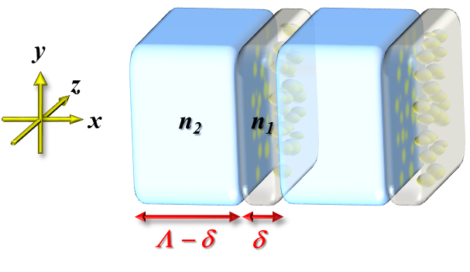
Figure 7. Scheme of the NGs periodic assembly of parallel thin disks of index n₁ (the porous nanolayer) and thickness δ spaced by a distance (Λ – δ) in a medium of index n₂ (usually a densified material in SiO₂) resulting in a strong form birefringence.

As said extensively above, the inner structures of NGs should be studied for further understanding the polarization-dependency. In fact, a number of researches have been conducted showing that the concentration of certain elements (like oxygen), in focal volume, appears to be periodically modulated leading to the formation of periodic arrays of alternating higher-density (n₂) and lower-density (n₁) regions. This anisotropic phenomenon (a so-called form birefringence) was confirmed by Bricchi et al.^{[78]} The periodically alternating nanoplanes are the consequence of polarization-dependency of NGs. Moreover, Lancry et al.^{[30]} revealed that the refractive index of oxygen deficient regions (namely nanoporous planes) was 0.20 lower than the raw region in silica glass. Further confirmed by Desmarchelier et al.^{[77]} who indicated that the mesoporous nanoplanes presented a decreased refractive index n₁ down to 1.25 due to the nanopores and the compressive stress between the nanolayers caused a slight densification resulting in n₂ $≈$ 1.46. Interestingly, as for the decrease of refractive index n_{sg} (the local refractive index of region surrounding nanopores) $≈$ 1.40, it can be explained by an irreversible volume expansion (e.g. caused by increase of local fictive temperature) or the low-refractive-index matter in-between nanopores consisting of Frenkel oxygen defect.

Polarization-dependent anisotropy: This polarization-dependent anisotropy was one of the most intriguing phenomena of fs-laser induced NGs in glasses which directly attributed fs-laser to a flexible tool for controlling nanoplane azimuth by changing the polarization. That is, periodic nanoplanes were usually perpendicular to the laser polarization direction, like the first observation^{[59]} in silica glass (Figure 3j). Zhang et al.^{[79]} revealed that by using a low-repetition-rate (1 kHz) fs-laser, optical birefringence varied with the polarization plane azimuth of the fs-laser and scanning orientation. The authors fabricated a light attenuator inside silica glass based on polarization-dependence of NGs. They depicted that the maximum attenuation ratio is roughly 24.5% at a single layer and the ratio can be further improved by forming a multilayer NG structure (maximum attenuation ratio of 36% for double-layer), as shown in Figure 8a. Interestingly, Dai et al.^{[80]} suggested that the orientation of NGs depended on the correlation between the tilted intensity front and the polarization plane azimuth, see Section 2.4.1 about PFT. They attributed this phenomenon to an additional modulation of electron plasma induced by the electric field (i.e., PFT which is caused by spatio-temporal distortions due to group-velocity dispersion during the light propagation in a dispersive medium (e.g., transparent dielectrics or microscope objective) and will be discussed later) along the pulse propagation direction. Moreover, they depicted that E// (sub-vector of incident electric vector E) $≈$ E$∙$cos$θ∙$sin$φ$, as illustrated in Figure 8c, played a key role in the formation of NGs and for E// = 0 ($θ$ = 90$°$) the NGs rotated to the intrinsic orientation perpendicular to E, which was the most common type of NG structure.

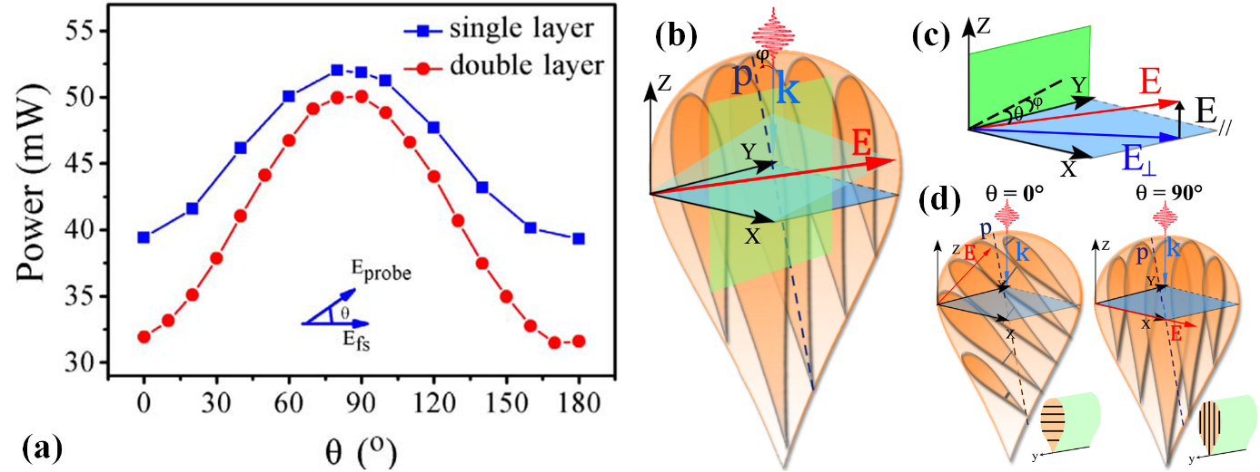
Figure 8. (a) The dependence of power on the angle between the polarization plane azimuths of the probe and the fs laser. Reproduced with permission from ref.^{[79]} Copyright 2013, Optical Society of America. (b) Schematic of the experiment using tilted fs pulses with k the wave vector of incident light and $φ$ the angle between the wave vector k and the Poynting vector p. (c) A resolution of the incident electric vector E for two sub-vectors $E_{∕∕}$ and $E_{⊥}$ with $θ$ the polarization plane azimuth. (d) The formation of periodic nanostructures in the traversal cross-section of the writing lines is demonstrated at $θ$ = 0$°$ or 90$°$. The lines are written along +y or -y directions. Reproduced with permission from ref.^{[80]} Copyright 2012, Optical Society of America.

Consequently, light velocity was different in the propagation direction perpendicular and parallel to the nanoplanes due to periodically alternating refractive index distributions, resulting in optical anisotropy, i.e., optical fast/slow axis properties. This was the reason why NGs presented strong form birefringence like a uniaxial birefringent crystal. Also, the birefringence amplitude and orientation can be assessed through quantitative spectro-polarimetric measurements, e.g. based on Mueller ellipsometry. Up to date, a number of investigations have been carried out in this field to understand their unique physicochemical properties including anisotropic light scattering, optical birefringence and thermal stability which were attractive features for optical applications in micro/nanoscale.

2.3.2. Optical scattering losses

Beresna et al.^{[81]} demonstrated that NGs presented high photo-induced scattering losses in UV and Vis ranges. The main reason behind the optical losses exhibited by the NGs was Rayleigh scattering (nanoporous nature), which presented roughly a 1/$λ$⁴ dependence on wavelength. The authors elucidated that second harmonic (532 nm) irradiation can lead to higher total losses and stronger modifications compared to the first harmonic (1064 nm) due to its higher energetic quanta. They also indicated that lower scanning speed can result in smaller optical losses. Lower losses can be observed for wavelengths from 200 to 300 nm after the erasure of defects. Indeed, NGs present significantly higher optical scattering compared to Type I modification. Also, Beresna et al.^{[81]} indicated the polarization-dependent characteristics of the optical scattering of NGs, i.e., higher losses were observed for polarization oriented perpendicularly to the nanolayers. Wang et al.^{[82]} compared the transmittances of 20-layer based on NGs and Type X structure (an early structure of NGs, see the following) and indicated that the transmittance of NGs reduced to around 20% at 20-layer of voxels with respect to that of Type X (99%).

2.3.3. A very high thermal stability

Thermal stability of NGs at an elevated temperature was frequently a core issue for optical components applied in harsh environments such as aeronautics, noble metals recycling, underground applications (e.g. deep drilling), next generation of nuclear reactors or Tokamaksr,^{[83]} or Structural Health Monitoring applications. Since the first observation of NG by SEM, many investigations focusing on its thermal stability have been performed. In 2006, Bricchi et al.^{[78]} revealed that the birefringence of laser induced regions, $β=∣n_{e}-n_{o}∣$, decreased with temperature. Here, they extracted two laser-irradiated zones with different pulse energies (i.e., E₅ = 1.6 µJ, E₆ = 2.14 µJ) for displaying this trend. Moreover, these samples were heated with a rate of 3 °C/min, kept at 200 °C for 1 h and cooled to room temperature at 1 °C/min. Besides, they repeated the annealing step at 500, 800, 1100, and 1400 °C. They found that Type I modifications degraded by a factor of 0.4 at 800 °C and disappeared after annealing at 1100 °C, whereas induced NG regions could be observed even upon annealing at 1100 °C. Interestingly, in 2006, Grobnic et al.^{[84]} revealed that IR-fs Type II modifications (NGs) did not decay after 150 h at 1000 °C, i.e., NGs maintained the refractive index modulation $∆n_{mod}$= 1.7 × 10⁻³ at high temperature, which is suitable for sensor applications up to 1000 °C. Kazansky et al.^{[85]} denoted an experimental evidence as the “Superman memory crystal”, as the glass memory has been compared to the “memory crystals” used in the Superman films, i.e., the data are recorded via self-assembled nanostructures created in SiO₂.
More recently, Wang et al.^{[86]} investigated the normalized retardance (unique optical properties of NGs) as a function of the annealing temperature inside SiO₂ glass, under three different annealing conditions (i.e., the isochronal annealing time at 0.5, 3 and 18 h, respectively). They revealed that retardance fully erased after 0.5 h at 1350 °C. Meanwhile, the authors also demonstrated the thermal stability in various transparent materials, including sapphire-derived fiber, yttrium aluminum garnet (YAG)-derived fiber, SiO₂ and SMF-28, as shown in Figure 9a.^{[22]} Here, they indicated the sapphire-derived fiber (51.5 mol.% Al₂O₃-containing aluminosilicate fiber) presented highest thermal stability, i.e., the optical retardance can survive at high temperature, until 1175 °C. They also reported the three temperature regimes of the decrease of normalized retardance: 1) 700 – 900 °C, due to the relaxation of Si-O three- and four-member rings; 2) 900 – 1075 °C, due to the relaxation of stress birefringence; 3) 1075 – 1200 °C, due to the erasure of nanopores and hence the steep decrease of form birefringence.

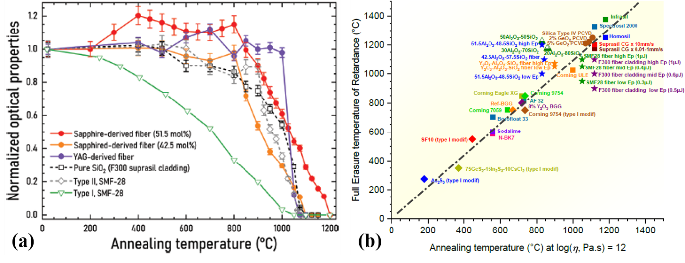
Figure 9. (a) Normalized retardance vs. the annealing temperature for various transparent materials (two sapphire-derived fibers (red and orange), SMF-28 and pure SiO₂ (grey and black), and YAG-derived fiber (purple)). The Type I modifications in SMF-28 (green) are shown for sake of a comparison. “Optical properties” are the normalized retardances for all the data excepted for Type I, SMF-28 (inhomogeneous index variation). Reproduced with permission from ref.^{[22]} Copyright 2022, John Wiley & Sons. (b) Temperature relative to the full erasure of optical retardance versus glass annealing temperature (°C). The annealing temperature is correlated with viscosity at log(η, Pa∙s) = 12.0. All measurements were obtained based on 30 min step isochronal annealing and done at room temperature. Reproduced with permission from ref.^{[87]} Copyright 2024, Elsevier.

In order to appropriately evaluate the industrial potential of NGs induced by fs-laser inside transparent materials, the temperature related to the full erasure of optical retardance (or refractive index changes for Type I modifications) as a function of glass annealing temperatures (°C) was recently reviewed as illustrated in Figure 9b.^{[87]} The glass annealing temperature (i.e. the temperature at which the viscosity is log(η, Pa∙s) = 12.0) is correlated to the erasure of these nanostructures and related birefringence (proportional to the measured optical retardance).^{[88]} Generally, the higher the glass annealing temperature, the more stable are the imprinted optical properties. These investigations confirmed that fs-laser induced NGs exhibited pronounced heat resistance which is beneficial for applications of optical devices at very high temperature. However, there still exist several problems on thermal stability of NGs, such as the high fragility of silica fiber at these high temperatures (above 1000 °C) and drift of the imprinted optical components under such high temperatures. Therefore, performing much work of this field is necessary to develop novel dedicated optical materials with high thermal resistance which are also suitable for NGs formation.

2.3.4. Optical chirality
First it is worth highlighting that chirality has two types of origins, namely intrinsic chirality (mainly refers to the chiral material with a chiral molecular arrangement at the nanoscale) and extrinsic chirality (i.e. a chiral object with experimental arrangement different from its mirror image, for example, oblique incidence or chiral arrangements at the micro-meter scale). Optical chirality can be described using the circular birefringence (CB) and the optical rotation. CB is defined as the difference of phase between left- and right-handed circularly polarized beams: $CB=\frac{2π}{λ}\left(n_{-}-n_{+}\right)∙d$ (radians). Similarly, circular dichroism (CD) is defined as the difference of absorption between left- and right-handed circularly polarized beams, which is usually described by $CD=\frac{2π}{λ}\left(κ_{-}-κ_{+}\right)∙d$ (radians) and results in an elliptical light polarization.
Several reported phenomena such as “Quill” effect,^{[89]} shear stress induced field^{[63,90]} and the creation of oriented anisotropic defects^{[91]} implied the possibility of achieving oriented and eventually asymmetric imprinting in center-symmetric matter.^{[92]} Poumellec et al. in 2003^{[63]} and later in 2008^{[90]} confirmed that light-matter interplay could cut a material like a scissor, moving matter in two opposite directions in response to the laser scanning direction and beam polarization direction. That is, considering the light propagation axis, an achiral beam focused into an achiral material in an achiral geometry could create a chiral strain, which was confirmed by Taylor et al.^{[93]} but using circularly polarized light.
Later in 2016, Poumellec et al.^{[94]} made one step further, i.e. they imprinted chiral optical properties inside fused silica using a linearly polarized Gaussian beam. The form birefringence of NGs was accompanied by a significant circular dichroism. The authors also observed a parity violation whose suggested mechanism was associated to a volume torque due to the combined action of a stress field and a direct current (DC) electric field. This torque originated from the misalignment between DC electric field ${\vec{E}}_{DC}$ and the material polarization field $\vec{P}$ and can be oriented using the PFT.
Figure 10. Measurements and modelling of chiral optical properties in SiO₂. (a) The schematic of the two contributions that lead to the laser induced circular property. (b) The schematic of 2-layers model consists of two linear retarders. Simulated evolutions according to of laser polarization compared with experimental results for CB (c), CD (d) and TLB (total linear birefringence) slow axis (e). Calculations and measurements done at 550 nm. Reproduced with permission from ref.^{[95]} Copyright 2023, Springer Nature.
Very recently, Lu et al.^{[95]} proposed a model for explaining the laser-induced optical chirality within silica glass as shown in Figure 10. This property was attributed to the co-existence of two phenomena: form birefringence-induced linear properties (linear birefringence and dichroism) and stress-induced linear birefringence. Besides, the misalignment between eigen axes of these two contributions resulted in a symmetry breaking and created chiral optical properties (CB and CD). It is worth pointing out that one can tailor both the amplitude and sign of the circular properties by adjusting the optical design and laser parameters. In addition, this approach can be implemented with a multilayer strategy to achieve on-demand optical rotation within less than 200 μm.^{[96]} Lastly in 2023, Lu et al.^{[97]} reported an “helically polarized” Bessel beam that allowed imprinting “twisted NGs” in SiO₂ glass resulting in an extrinsic optical chirality at a micrometric scale, which owned a high optical rotation i.e. twice as large circular birefringence with, simultaneously, four times smaller linear birefringence compared to a 45° linearly polarized fs Bessel beam or Gaussian beam.
This ability to manipulate optical rotation opens possibilities to optical property engineering of any given transparent material. For instance, producing chiral waveplates^{[96]} and developing birefringent-based devices such as passive optical isolators, achromatic birefringent components that can be exploited for polarimetry, photonics integrated circuits, advanced laser beam shaping^{[98]} or spectroscopy.

2.3.5. Erasing/rewriting capability

As illustrated above, fs-laser pulse could impact the size and azimuth direction of nanoplanes and chemical elements re-distribution. Therefore, could we speculate that the subsequent fs-laser pulse with polarization direction different from the previous one, can re-change the nanoplanes azimuth and chemical elements distribution? Indeed, this process can be simply described by the phenomenon that the nanocracks induced by the previous pulse were easily erased and rewritten by the following pulse due to lower ionization threshold of laser-irradiated region (more breakdowns). Moreover, a carrot-like shape (Figure 4c) in space formed due to self-focusing, spherical aberration and other nonlinear effects was observed at the cross-section view in laser focal volume of silica glass through SEM. As for erasing and rewriting process, Taylor et al. have given rise to direct experimental evidences and complete descriptions.^{[62]} That is, nanocracks erasure process could be considered as a form of laser annealing due to high peak power of fs-laser pulse, and the following different pulses heat the material slowly erasing the previous nanocracks through viscous flow of silica in focal volume, meanwhile the new formed nanocracks emerge reinforced by the electric field of rewriting laser pulses. In authors’ experiment, 3, 30, 300 and 4000 laser pulses were used for different spots with various polarization azimuths, as shown in Figure 11a-d. They immediately revealed that new nanostructures began to grow out of old ones along with the rewriting laser pulse numbers. In the case of low rewriting pulse number, the small nodules (see Figure 11a) of material modification were oriented perpendicularly to the rewriting laser polarization and grew generally from spots of increased modifications or damaged portions of the previous nanolayers, due to lower ionization threshold. Eventually, NGs with new azimuth sprouted from the initial ones. The corresponding birefringence intensities of initial and rewritten NGs are presented in Figure 11e. Importantly, the erasing/rewriting capability shows the prime and flexible characteristics of NGs,^{[99]} like errors re-correction, which could be applied in 5D optical information due to the similarity to the recording and deletion of information. The self-assembled nanostructures change the way light travels in glass, modifying the polarization of light that can subsequently be read by a combination of optical microscope and a polarizer, which is similar to what found in Polaroid sunglass. Indeed, Taylor et al.^{[62]} wrote “SIMS SIMS” containing a series of voxels (around 2 µm) with intentional error: the third letter “S” was rewritten by a laser which produced nanolayer azimuth about 45° oriented to the initial azimuth. The study clearly evidenced the effectiveness of erasing/rewriting of NGs which could be potentially applied in optical data storage.
Moreover, Zhang et al.^{[100]} have further investigated this capability by using ultrashort double-pulse sequences irradiation in silica glass. For further clarifying the nature of erasing/rewriting of NGs, the authors analyzed different polarization states of individual pulse, interpulse temporal delay and the corresponding energy ratio of double-pulse, as illustrated in Figure 11f-k. Here, they indicated the energy ratio was the prime factor for erasing/writing of NGs due to the dependence of NGs formation on pulse energy deposition process.
All that mentioned above presents the nature of NGs inner structures and related characteristics, and this may provide the scientists with more inspirations for the corresponding designs of optical components in the future.

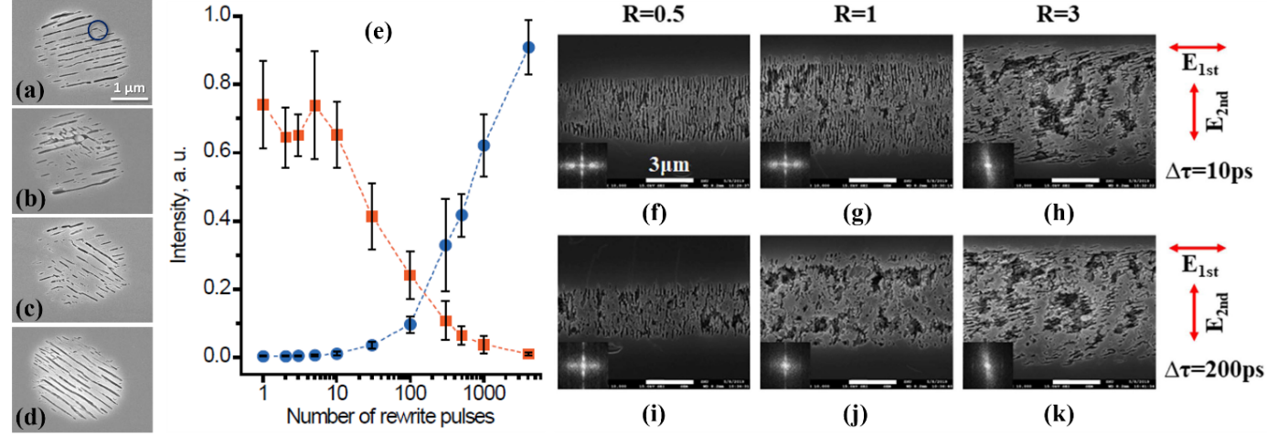
Figure 11. Evolution of grating morphology in SEM images as a function of number of rewriting laser pulses: (a) 3 pulses (the circle highlights a nascent crack growing in the re-oriented new direction), (b) 30 pulses, (c) 300 pulses and (d) 4000 pulses. Initial voxels were produced using 4000 pulses and the rewriting polarization is 45° to the original polarization. (e) Intensity of birefringence as a function of number of rewriting pulses with (■) the birefringence intensity from the original NGs and () the birefringence intensity from the evolving replacement voxels. Reproduced with permission from ref.^{[62]} Copyright 2008, John Wiley and Sons. The process of erasing and rewriting of NGs by using cross-polarized double-pulse sequences with varied energy ratios: (f)-(h) and (i)-(k) with $∆τ$ of 10 and 200 ps, respectively. The energy ratios of double-pulse sequences are: (f) and (i) (R = the second pulse energy/the first pulse energy = 0.5), (g) and (j) (R = 1), and (h) and (k) (R = 3). The insets are 2D Fourier transformations of SEM images. Reproduced with permission from ref.^{[100]} Copyright 2020, IOP Publishing Ltd.

2.4. Parameter dependencies of NGs formation
To date, various parameters are frequently studied in light-matter interaction including pulse duration,^{[67]} pulse energy,^{[15,101]} pulse repetition rate,^{[102,103]} wavelength,^{[104]} polarization orientation,^{[105]} NA,^{[74]} laser writing velocity,^{[106]} space-time couplings (namely, simultaneous spatial temporal focusing (SSTF) and PFT etc.),^{[89,107-109]} double-pulse^{[110]} and chemical composition,^{[111]} which provided the various types of influence on the formation of NGs. Considering the limited scope of the review, and a few already reported work^{[27,104,112]} on parameters dependencies of NGs formation, this section will be simply focused on those parameters which allow to briefly gain the basic overview of self-organized nanostructures engineering.

2.4.1. Influence of the main laser parameters
The intrinsic laser parameters such as pulse duration, pulse energy, pulse repetition rate, laser scanning velocity, wavelength, polarization can directly determine laser characteristics further controlling NGs formation. Additional parameter conditions, such as NA, PFT and double pulse are frequently hot spot studies of NGs.

Pulse duration: slightly longer pulse duration^{[41,67,113,114]} (around 1 ps) can improve the optical retardance of NGs due to 1) laser-irradiated longer tracks and 2) more efficient nonlinear absorption of free electrons. In addition, Zhang et al.^{[115,116]} recently revealed 1 ps was a good choice for obtaining the high retardance in their study.
Pulse energy: Poumellec et al. presented the formation threshold of each laser-induced modification according to energy.^{[15]} Optical retardance increased with pulse energy due to stronger nonlinear effect leading to higher plasma density and then decreased due to laser ablation and material melting which broke the structures of NGs.^{[81,117,118]} Moreover, Zhang et al. elucidated that 1 µJ can induce highest birefringence in La₂O₃-Ta₂O₅-Nb₂O₅ (LTN) glass,^{[115]} in comparison with other energies in their study.
Repetition rate: pulse repetition rate is frequently correlated with thermal accumulation effect. Xie et al.^{[2]} demonstrated that Type II (i.e., NGs) energy window diminished with repetition rate (from 10 up to 1000 kHz) in various transparent glasses (such as SiO₂, GeO₂, Soda-lime, ULE, BK7, 7059, Eagle XG, AF 32 and Borofloat 33). However, at very high repetition rate (10 MHz) nanopores inside the NGs^{[111]} would be erased due to local high temperature and material melting leading to the decrease of retardance.^{[117]} Recently, GHz repetition rate laser was reported for its higher ablation efficiency and quality due to ablation cooling process^{[119]} by Sugioka et al.
Wavelength: wavelength can determine the period (Λ = λ/2n, where n is the refractive index^{[120]}) of NGs, photon dose and beam radius which lead to either different local intensity distribution of laser, nonlinear absorption efficiency^{[104]} or various optical losses in the UV-Vis range.^{[121]}
Pulse number & Laser scanning velocity: pulse to pulse effect can impact the NGs formation. Generally, NGs period was decreased with continuously increasing pulse number.^{[117]} Sakakura et al.^{[122]} reported an intermediated structure of NGs, called “Type X”, whose morphology was continuously elongating perpendicularly to the direction of laser polarization and retardance increased with pulse number. Besides, Zhang et al.^{[115]} elucidated that enough pulse number (1000k) improved continuous periodic crystallization process of crystallization-based NGs in the study. Alternatively, some authors are playing with laser scanning velocity which is similar factor affecting to cumulated fluence. For example, Beresna et al.^{[81]} showed a high optical retardance (>300 nm in the visible range) for relatively low velocity (typ. below 1-2 mm/s) while it is lower but still exploitable for higher speed (10 mm/s). Generally, scanning speed can be roughly transformed into pulse number on the dots (i.e., N_{p} = (R. R/v)*D, N_{p} is the pulse number on the dot, R. R is repetition rate, v is writing speed and D is the diameter of dot).
NA: using tight focusing can provide a lower value of retardance^{[15]} but higher spatial density of “printed data”. Lancry et al.^{[74]} elucidated that keeping a relatively low NA is a good approach to get high optical retardance due to longer birefringent structure, for instance, an optical retardance much above 300 nm at 0.1-0.2 NA objective.^{[81]}
Double-pulse: double-pulse is generally a method to investigate the dynamics of laser-matter interaction. Wortmann et al.^{[123]} obtained the lifetime of STE (400 ps) by using double-pulse indicating the significance of double-pulse as a tool of investigation. Richter et al.^{[124]} showed polarization contrast intensity (PCI) decreased with temporal separation of double-pulse due to the decay from STEs to point defects. Actually, as early as 2010, Shimotsuma et al.^{[125]} have systematically investigated NGs formation based on double-pulse. The authors indicated lower temporal separation of double-pulse would produce higher thermal accumulation which can deteriorate NGs. Later, the authors studied once more the control of form birefringence using temporally shaped double-pulse in SiO₂ glass.^{[126]} Wang et al.^{[127]} revealed the remaining electrons induced by 1st pulse could be more easily re-excited by the subsequent pulse in their double-pulse experiment based on NGs, again confirming rationalization of memory effect. Zhang et al.^{[100]} suggested the controlling of energy ratio in double-pulse sequence also played a decisive role during NGs formation.
Pulse front tilt (PFT): PFT is a phenomenon which is often encountered for broadband ultrashort pulses. Pulse front tilts can arise in various situations: dispersion prism or a diffraction grating, slightly wedged optical components. The most common way is when a linear pulse compressor based on a prism pair, or a pair of diffraction gratings exhibit a slight misalignment resulting in angular dispersion or PFT. This can be described as a tilt in the intensity front relative to the phase front arising from the couplings of angular dispersion (AD = $\frac{dθ_{0}}{dω}$, where $θ_{0}$ is the angle of deviation and $ω$ is the angular frequency) and spatial chirp (SC). Bor et al.^{[128]} and Hebling et al.^{[129]} proved PFT is generally equivalent to AD. Another proof was provided by Dorrer et al.^{[130]} using Fourier transform. However, Akturk et al.^{[131]} revealed PFT =${PFT}_{AD}+{PFT}_{SC+TC}$, where TC is temporal chirp. That is to say, PFT equals to AD only for beams without spatial and temporal chirps. Subsequently in 2007, Kazansky et al.^{[89]} reported direction-dependent “Quill” writing effect caused by PFT. Beresna et al.^{[132]} depicted the intensity of beam of light polarized along PFT was stronger than that of polarization perpendicular to PFT. The authors thought at pre-focus area the pondermotive forces associated with gradient PFT could more effectually remove the defects from the light path for polarization along PFT decreasing photon losses. Dai et al.^{[80,133]} denoted the dependency of NGs direction on scanning direction, polarization and PFT. It can be explained that ponderomotive forces perpendicular to the tilted intensity planes push or trap the electron plasma forward in the pulse front when the Poynting vector has a horizontal sub-vector along the scanning direction, resulting in easier excitation of free electrons by the subsequent pulse due to memory effect and lower ionization threshold of STEs. Recently, Li et al.^{[134]} additionally reported the impact of wavefront rotation (WFR) on PFT for further understanding asymmetric distributions of pulse intensity and free electron density in the presence of PFT.

2.4.2. Material chemical composition

Light-matter interaction governed the formation of self-replicated nanostructures implying material chemical composition should also be considered during NGs formation process. Different doping impurities within transparent solids could directly change material’s photosensitivity, viscosity, glass transition temperature, density, Young's modulus, bandgap (e.g., 9 eV for silica) etc. Recently, Sun et al.^{[135]} achieved perovskite nanocrystals with tunable composition and bandgap in glass, controlling halide ion distribution, by using 3D direct lithography. Interestingly, Type I modification threshold was not influenced apparently by composition doping.^{[3]} Besides, to date, NGs have been achieved in not only SiO₂ but also GeO₂ glass, TeO₂ single crystal, Sapphire, Al₂O₃-Dy₂O₃ binary glass, or titanium silicate glasses (ULE, Corning)^{[3,4,111,136-142]} through adjusting the laser parameters. There are several categories of NGs and the most popular is the one primarily revealed in SiO₂ glass.^{[13]} The other one is NGs composed of alternative periodic crystalline and amorphous regions, like the case in lithium niobium silicate (LNS) glass^{[143,144]} or patterned crystal precipitation in LTN glass.^{[1,115,116]} Surprisingly, NGs are also found in crystals like Si, GaP, 4H-SiC, GaN, GaAs or YAG,^{[75,145-148]} and very recently in Ge-Sb-S glass^{[149]} which overstep the scope of the review. Here, this section will be classified into two sub-sections: (1) laser-induced NGs containing nanopores; (2) laser-induced NGs containing partial crystallization. For more details, a critical overview of the discovery of NGs in multicomponent glasses was published in 2023,^{[87]} this provides a materials roadmap for inscription of NGs inside transparent dielectrics.

Laser-induced NGs containing nanopores: Lancry et al.^{[3]} showed that the threshold of strongly linear birefringence (NGs) apparently depended on composition dopants in the glass. The authors revealed Ge-doped silica possessed smaller NGs formation threshold (0.14 $±$ 0.05 µJ) compared to that (0.31 µJ) of silica due to Ge easily behaving as a trapping center forming Ge(1) center compared to silica. Besides, P-doped silica presented similar properties, while F-doped glass showed opposite results due to its difficult decomposition of glass network structure. Indeed, doping can also impact the aspect ratio of nanopores.^{[150]} Shimotsuma et al.^{[137]} reported Cl-doped fused silica can yield larger birefringence compared to SiO₂ and NGs of anion-doped silica possessed high thermal stability. Moreover, Wang et al.^{[151]} reported the dependency of morphology and period of NGs on Na-doping in germanate glasses. Recently, Yao et al. elucidated the observation of NGs not in barium gallo-germanate (BGG) glass doped with Na, K, or La^{[35]} but in that doped with Ta, Gd, Y, or Zn.^{[41]}

Laser-induced NGs containing partial crystallization: Laser-induced crystallization in transparent dielectrics has drawn wide attention due to its potential photonic applications.^{[152,153]} Under intensive investigation in the field of NGs, another type of NGs (containing crystalline phase) in LNS glass was reported by Cao et al.^{[143]} The authors utilized a high-resolution (HR) TEM and selected area electron diffraction (SAED) to obtain a clear picture of the crystalline properties in the black or gray regions (nonlinear nanocrystals) and the white regions (vitreous “walls”) of the laser-induced nanostructures, as in Figure 12a and b. Later, in 2019,^{[154]} the authors further completed the related complex crystallization mechanism in LNS glass by introducing 3 regimes (1: modifications of amorphous structures. 2: occurrence of nanocrystals between the amorphous lamellas. 3: dependence of crystallization morphology on laser scanning direction and polarization). NGs containing Dy₃Al₅O₁₂ garnet and DyAlO₃ perovskite crystal, induced by ultrafast laser in Al₂O₃-Dy₂O₃ binary glass, were also reported.^{[142]} Interestingly, partial crystallization of NGs inside Na₂O-GeO₂ binary glasses was reported by Lotarev et al.^{[155]} in 2019. They revealed the partial crystallization inside NGs with the precipitation of Na₂Ge₄O₉ crystals (major) and Na₄Ge₉O₂₀ crystals (minor), as shown in Figure 12c. Furthermore, Zhang et al.^{[115,116]} reported self-assembled crystallite-based NGs in multicomponent LTN glass and indicated heat accumulation caused by ps-laser and Ta₂O₅ content played a crucial role in crystal growth. Recently, the authors^{[1]} reported, once again, laser-induced NGs containing partial crystallization in LTN glass, as illustrated in Figure 12d and e, based on the approach of self-organized phase-transition lithography (SOPTL). They indicated the existence of LaTa_{x}Nb_{1-x}O₄ and Ta₂O₅ crystals in the processed area by ultrafast laser irradiation and envisaged the potential paths for various frontier photonic applications, as environmental sensors, photonic crystals, and nonlinear optics. From mechanisms point of view, a scenario was suggested to interpret the nanoscale chemical separation that is initiated before the crystallization. The idea is based on light “forced-organized” plasma imprints its spatial distribution on the chemical separation^{[156]} that is driven by electrochemical potential gradient related to the various glass constituents.^{[157]} Following this view, there is an additional electrochemical force super-imposed to the thermal one (thermodynamical phase separation), leading to the formation of these partly crystallized NGs.

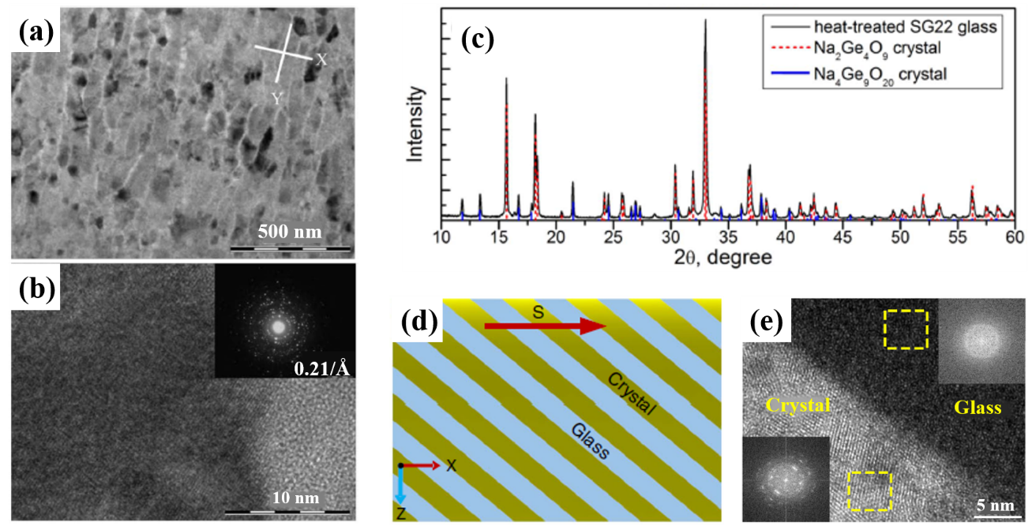
Figure 12. TEM (bright field mode) graphs of fs laser-induced NGs: (a) overview of the focused ion beam (FIB) slice in the XY plan and (b) HRTEM graph showing a magnification on a single nanoplane (inset is the SEAD pattern). Reproduced with permission from ref.^{[143]} Copyright 2016, Optical Society of America. (c) X-ray diffraction pattern of the heat-treated SG22 glass, and line diagrams of Na₂Ge₄O₉ and Na₄Ge₉O₂₀ crystals. Reproduced with permission from ref.^{[155]} Copyright 2019, Optical Society of America. (d) Schematic illustration of the expected morphology of the created photonic structures. S: the beam scanning direction. (e) HRTEM graph of the crystal and glass region of the photonic textures. Insets are the fast Fourier transform (FFT) images from the dotted areas. Reproduced with permission from ref.^{[1]} Copyright 2021, Springer Nature.

2.5. Models of volume NGs formation

2.5.1. Plasmon-photon interference
In 2003, Shimotsuma et al.^{[13]} have firstly proposed a model based on the interference between the incident light field and the electric field of the bulk electron plasma wave, which subsequently resulted in periodic modulation of NGs. The complete physical process of electron dynamics was presented: in the laser focal volume inside fused silica glass, certain free electrons, so-called seed electrons, preferentially excited by multi-photon ionization subsequently absorbed pulse energy via single photon absorption due to inverse bremsstrahlung. Subsequently, more hot electrons happened due to impact ionization, forming a bulk electron plasma. This quasi-free electron plasma oscillates in the form of a plasma density wave, i.e., a longitudinal wave whose direction is parallel to the electric field $\vec{E}$. When orientation of $\vec{E}$ is coplanar with polarization of incident light, an efficient coupling will occur. Thus, free electron densities are periodically modulated. Overall, through the mechanism of interference between incident light-field and electron plasma wave, the plasma density is periodically modulated and will further imprint its spatial structure within the glass material. On one hand, abundant plasma electrons, Si$=$Si, non-bridging oxygen-hole centers (NBOHCs), and a few oxygen atoms/ions were concomitantly formed due to the non-linear ionization that resulted in the fracture of Si-O-Si sequence of silica glass network. Moreover, oxygen atoms will migrate from the high-density region to the lower region due to ultrahigh pressure produced by fs laser whilst oxygen ions also migrated as a result of repulsion of high-density electrons. The presence of defects (E’, ODC, NBOHC and color centers etc.) inside glassy materials leading to the preferential ionization of transparent materials corresponded to the region of low oxygen density which will further form nanopores being a part of NGs. On the other hand, the period $Λ$ of NGs was predicted to be dependent on the optical wavelength, plasma temperature and density,^{[13]} as follows:
$Λ$ = $\frac{2π}{\sqrt{\frac{1}{T_{e}}\left(\frac{m_{e}ω^{2}}{3k_{B}} - \frac{e^{2}N_{e}}{3ε_{0}k_{B}}\right) - k_{ph}^{2}}}$ (5)
where T_{e} = A($Λ$) - B($Λ$)N_{e}, A($Λ$) = (m_{e}$ω$²)/(3k_{B}k_{pl}), B($Λ$) = e²/(3$ε$₀k_{B}k_{pl}) and A($Λ$)/B($Λ$) = $N_{e}^{cr}$(critical plasma density), m_{e} is the electron mass, k_{B} is Boltzmann constant, and k_{pl} is electron plasma wave vector equal to $\sqrt{k_{ph}^{2}+{\left(\frac{2π}{Λ}\right)}^{2}}$ with k_{ph} = $ω$n/c (wave vector), $ω$ is the angular frequency, n is the refractive index, and c is light speed. The grating period will increase with the pulse energy and electron temperatures, as shown in Figure 13a.
However, this interference model needed a plasma density, N_{e}, close to the critical one and an ultrahigh electronic T_{e} (10⁷ K) that was contradicted to the formation of NGs in Ref.,^{[62]} i.e., the applied laser energy is insufficient to satisfy the required plasma temperature and density indicating the deficiencies of this model. Besides, Richter et al.^{[117]} have indicated that the period $Λ$ of NGs monotonously increased with the laser wavelength or scanning velocity, but decreased with the number of applied pulses, as shown in Figure 13b and c. Therefore, the substantial experimental observation challenges this interference model, namely, the impacts of laser wavelength, scanning speed and number of pulses on the NGs period $Λ$ need to be clarified.

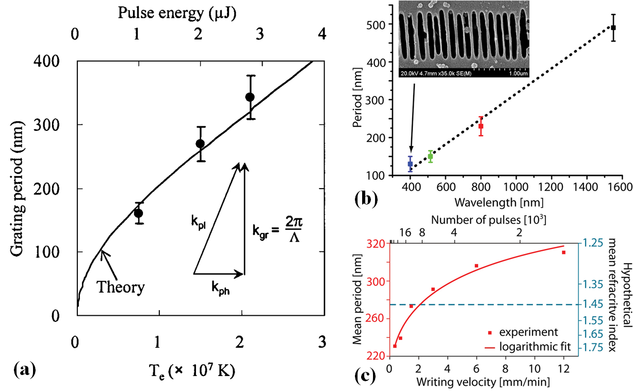
Figure 13. (a) Experimental grating periods versus pulse energy and theoretical dependence of self-organized NGs period on electron temperature for electron density n_{e} = 1.7 × 10²¹ cm⁻³ are shown with inset a wave vector matching diagram. Reproduced with permission from ref.^{[13]} Copyright 2003, The American Physical Society. (b) The minimal period of NGs is proportional to the wavelength $λ$ of incident laser. Inset presents the SEM micrograph of aligned NG at $λ$ = 400 nm. (c) The period of NGs depends strongly on the laser pulse number, although the overall behavior generally scales with the incident wavelength. The period of mature NGs is generally determined by half the wavelength in the material (here $λ$ = 800 nm^{[158]}). The large variation of the NGs period cannot be attributed to a hypothetical change of the refractive index (n = 1.45 for raw fused silica, dashed line). Reproduced with permission from ref.^{[117]} Copyright 2012, Laser Institute of America.

2.5.2. Transient nanoplasmonic model

In 2006, Bhardwaj et al.^{[120]} have firstly proposed the nanoplasmonic model explaining many phenomena, such as impact of local field enhancement on dielectric ionization, on nanolayer growth and why the nanolayers were arrayed, to name a few. Later, in 2008, Taylor et al.^{[62]} have described the principle of nanolayer formation and the process of nanolayers self-ordering to form grating patterns. In general, naturally existent defects inside glasses exhibit relatively low ionization threshold with respect to the glass pristine area, as elucidated above, leading to inhomogeneous distribution of ionization and energy absorption at focal spot inside dielectric under the action of the first several pulses and create a few random centers of ionization. These random centers of ionization will be developed to nanoplasmons under the irradiation of subsequent laser pulses, accompanied by an increase of the ionization rate in the laser-irradiated region, and this increase is a positive-feedback process based on the memory effect, leading to the increase of plasma density. Subsequently, electric field near the equator will be enhanced with respect to the poles due to the boundary conditions leading to anisotropic characteristics, and therefore the expansion process of nanoplasmons presents significant anisotropy. The ellipsoidal nanoplasma is hence formed and presented in Figure 14a.

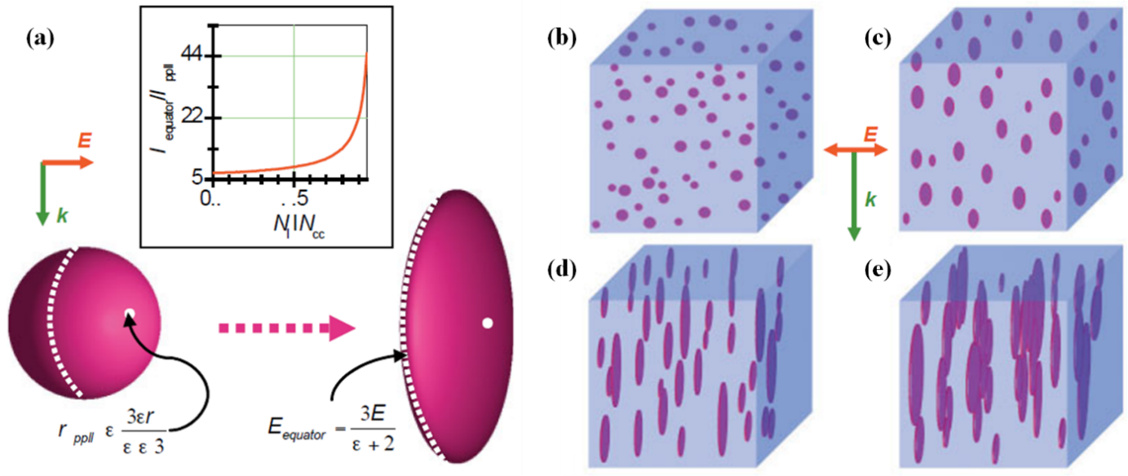
Figure 14. (a) Schematic indicating local field enhancement at two locations outside a nanoplasma under the impact of the laser electric field E. K is the direction of laser propagation. The relative permittivity $ε$ is the ratio of the real part of the nanoplasma permittivity to the dielectric function of the medium that surrounds the nanoplasma. The inset presents a measure of the magnitude of the asymmetric growth (E_{e}/E_{p}) as a function of N_{e}/N_{cr}, where E_{e} and E_{p} denote the local fields at the equator and poles of the sphere, respectively, for a total field E. (b)-(e) exhibit the evolution of nanoplasmas into nanoplanes. Randomly distributed underdense nanoplasma micro droplets (size is tens of nanometers) grow asymmetrically in the presence of the laser field over hundreds of laser pulses to turn into ellipsoidal and finally flatten and merge to become sub-wavelength nanoplanes. Reproduced with permission from ref.^{[62]} Copyright 2008, John Wiley and Sons.

The anisotropic growth rate of these nanoplasmas is accelerated when density of states of the equatorial plane edge reaches a critical value, which further leads to the formation of nanoplanes with their normal parallel to laser polarization (see Figure 14a). The initial nanoplanes are randomly distributed in focal spot. However, with incident pulses being cumulated, electron plasma density inside nanoplane is increased resulting in metalloid phase (i.e., semi-metallic properties) of laser-excited region. Therefore, interference between incident laser and electron plasma is achievable resulting in plasma periodic modulation. On the basis of the distributions of incident laser intensity and plasma density, overall process mainly occurs at the top of carrot-shaped modified structure in focal volume. In addition, the field distribution of lowest optical order mode improves the transformation from nanoplanes to quasi-metallic phase, hence the formation of self-organized periodic NGs, as schematically shown in Figure 14b-e. Overall, inhomogeneous breakdowns (i.e., color centers, STE, voids generated by the 1st pulse, glass free volume^{[159]}) in glass network are excited firstly, then formed plasma by multi-photon and avalanche ionization processes further lead to flat circular ellipsoid of plasma, due to anisotropic local field enhancement. Then a pulse-to-pulse memory effect triggers the subsequent pulse to provide feedback for the anisotropic breakdowns.
In this model, edge field intensity of inhomogeneous plasma is the main reason behind continuous formation of plasma and the initial formation of NGs. Moreover, phenomena of incubation effect and self-ordered growth under multi-pulse irradiation are commendably explained. However, the lifetime of excited plasma in focal spot is more or less 150 fs,^{[160,161]} thus several orders of magnitude lower than the interval between two continuous pulses (e.g., for pulse repetition rate of 100 kHz, the interval between two continuous pulses is 10 $μ$s). Therefore, this nanoplasmonic model is not accurate for explaining the interaction between nanoplasma and the subsequent pulse at focal point. In addition, Bhardwaj et al.^{[120]} attributed the spacing of nanoplanes to $Λ$ = $λ$₀/2n, where n is the refractive index of transparent dielectric and $λ$₀ is the free space wavelength, independent of pulse energy and delay. However, $Λ$ can be much shorter for higher pulses number (as shown in Figure 13c, which defies this model since it cannot be explained by reasonable changes of the mean refractive index n), or for different chemical compositions like Ge-doped silica or alumino-borosilicate glasses.^{[4,136]} Also, Liang et al.^{[162]} have revealed that the nanolayer width and the spacing between two consecutive nanolayers are decreased with incident pulse number during fs-laser irradiation on the surface of fused silica. They thought each excited nanoplasmon will enter local field distribution mode that is constituted by a central maximum with two-side-secondary-maxima during the interplay process. The side-maxima decrease gradually the ablation threshold in focal point and thus fission effect (i.e., with increasing the pulse number, the number of nanoplanes will be increased) occurs as a result of incubation effect.^{[163-165]} Therefore, more nanogrooves are formed leading to the increase of NGs density. Recently, the nanoplasmonic model has been ameliorated by introducing randomly distributed inhomogeneities (exhibiting a low dielectric constant compared to the background) as initial seeds for the process in fused silica,^{[166]} see the next sub-section.

2.5.3. Inhomogeneity-scattered waves interference

In addition, Buschlinger et al.^{[167]} proposed a model based on finite-difference time-domain method to explore plasma generation which mainly concentrated on the nano/micro-scale inhomogeneities, e.g., voids, in transparent solids. They found that the existence of nanoscale inhomogeneities could considerably amplify plasma generation and each inhomogeneity played a role of seed in generation of plasma growing against the direction of laser propagation. They revealed that plasma structures are found to interact strongly and to be regularly self-assembled and oriented perpendicularly to the laser polarization, in accordance with Refs.^{[13,120]} However, the model developed by Buschlinger et al. did not incorporate the impact of concentration of inhomogeneities (nor chemical composition dependence) on the NGs evolution, leaving some unexplained observations,^{[3,168,169]} e.g. the different doping contents of Ge, F, P in silica glass^{[3]} individually impact the threshold of NGs formation (in other words, glass decomposition). In Ref.^{[168]} increasing the concentration of NaCl solution (tuning the ionization potential) in which the porous glass is immersed can decrease the NGs period and the formation threshold, or the presence of noble metal ions (i.e. silver)^{[169]} can enhance and improve the formation of NGs (decreasing the formation threshold, smoothing NG shapes and presenting a bifunctional behavior), as a kind of catalytic-like. Subsequently, Rudenko et al. further completed this mechanism in Ref.^{[166]} based on numerical calculations from Maxwell’s and multiple rate carrier electron density equations. The authors splitted the acquired self-organized nanoplanes into two types: LFNGs (low-frequency nanogratings, the period of 𝜆/𝑛) and highly ordered HFNGs (high-frequency nanogratings, the characteristic period around 𝜆/2𝑛 or lower) which depended on the concentration of inhomogeneities, C_{i}, in their study. In fact, the periodicity may diminish drastically with the further increase of inhomogeneities concentration, C_{i}, until the nanoplanes merge, i.e., generation of uniformly distributed plasma over the irradiated region. This allows to explain several observations as the decrease of the period with increasing pulse number; more in detail, an ultrashort period down to 𝜆/10𝑛 was observed in multicomponent glasses.^{[87,166,167]} LFNGs and HFNGs are, respectively, from the interference of incident and inhomogeneity-scattered waves and that of several scattered waves due to mutual enhancement. In this mechanism, the nanometric inhomogeneities (seeds) played a crucial role guiding the whole process of volume NGs development. The literature suggests various potential seeds, either native to the glass or induced by laser pulses. Some studies have suggested an initial “nanovoid”,^{[166,167]} point defects centers,^{[62]} as well as transient defects like self-trapped electrons (STEs)^{[124]} and self-trapped holes (STHs)^{[170]}. Recent work reveals that glass free volume^{[159]} is also a good candidate for seeding this process of scattered waves interference. Interestingly, this model could be adapted for explaining both volume NGs and surface ripples.

2.5.4. A self-trapped excitons (STEs) based model

As denoted above, multiple laser pulses are responsible for the formation of NGs. Nevertheless, the coupling mechanism mediating the collaborative process of subsequent laser pulses was under debate. Also, the lifetime of active electron plasma was roughly confirmed to be 150 fs^{[160,161]} in fused silica, and in this case no free electron plasmas were living when the next pulse arrives, specifically for the repetition frequency range of kilohertz. Interestingly, Richter et al.^{[124]} revealed that even at repetition rate 0.1 Hz (10 s between two continuous pulses) NGs could be formed. The authors proposed that at room temperature STEs decay in a nonradiative manner and form semi-permanent point defects including E’-center ($≡$Si$∙$) with a dangling Si bond and NBOHCs ($≡$Si$-$O$∙$) with the oxygen dangling bond. Therefore, they identify the mechanism in two regimes to explain the cumulative action of laser pulses, according to the pulse interval time:
1. < 500 ps, the free electrons induced by nonlinear ionization were trapped by lattice distortions, which resulted in the formation of STEs. STEs could improve the nonlinear absorption of the following laser pulses due to the lower excitation energy from intermediated state to conduction band. Therefore, more excess energy could promote the formation of NGs. Besides, when the pulse separation exceeded the lifetime of the STEs (a fs-laser at a repetition rate of 1 kHz, viz., pulse separation of 1 ms), the mechanism would be in turn replaced by the resulting point defects, including NBOHCs, which would significantly reduce the energy of ionization with respect to the bandgap of the raw material.
2. > 500 ps, the point defects would be dominant and become a part of NG structures. As can be seen above, the random distribution of nanoscale inhomogeneities in glass could trigger nanoplasma formation by laser irradiation which favored the generation of NGs.^{[62,167]} These nanoscale inhomogeneities include a variety of defects (SiE’, NBOHCs and ODC) and lattice distortion trapping excitons, viz., STEs.
Under the multipulse regime, the hot plasma evolves into a spherically shaped nanoplasma. However, due to the local field enhancement at the boundaries of nanoplasma, the polarization sensitive growth of initially spherical nanoplasma will occur. When the plasma concentration is below the critical values, the electric field is enhanced at the equator leading to nanoplanes formation under a multi-pulse process.^{[120]} The final pattern leads to the period of 𝜆/2n.
Over the last two decades, many other mechanisms (e.g., the model of plasma standing wave,^{[171,172]} exciton-polariton mechanism^{[173]}) of NGs formation were, as well, proposed for the sake of completeness. Nevertheless, the debates and contradictions still existed during the NGs formation. Therefore, further investigations are necessary to clarify these novel findings of ultrashort laser-matter interaction and to gain a clear overview of the mechanisms of NGs formation. Furthermore, according to the lifetime of STEs the double-pulse irradiation method (see Section 2.4.1 double-pulse) was proposed for investigating the role of STEs.

2.6. Applications of femtosecond laser induced NGs
Since the first observation of NGs in silica bulk glass, numerous related experiments have been carried out due to a plethora of intriguing properties, such as anisotropic light scattering,^{[122]} highly selective etching^{[23]} and form birefringence correlated to a remarkable thermal stability,^{[78]} as previously mentioned. In addition, with the gradual discovery of NGs inside many transparent solid compounds^{[3,4,111,136-142]} or LNS, BGG glasses^{[41]} and even in multicomponent alumino-borosilicate glasses^{[2,113]} (Borofloat 33, Schott), as denoted in Section 2.4.2, the range of industrial and laboratory applications is, as well, enlarged. Moreover, practical application of NGs has been found in ultrastable 5D optical memory, microfluidics, phase waveplate, optical fiber attenuation, polarization selective holography due to various characteristics of NGs.

2.6.1. 5D optical data storage
Nowadays, digital data storage with the exponentially increasing amount of data in the information age is more and more on-demand. The magnetization-based storages (e.g., hard disk drivers (HDDs)) and magnetic tapes have also been developed, but HDDs show insufficient capacity, energy efficiency and relatively short lifetime,^{[174]} and the magnetic tapes present longer access latency and degradation. Deoxyribonucleic acid (DNA)-based data storage could have a capacity of hundreds of terabytes per gram but the durability is restricted.^{[175]} Additionally, conventional optical data storage which is based on planar technology, like compact discs (CDs) and digital video discs (DVDs) have a capacity of hundreds of gigabits per disk and can only be preserved down to a decade.^{[176-178]} The first optical recording induced by fs-laser in photopolymers was demonstrated in Ref.^{[179]} Also, there are some researches concentrated on high capacity optical recording based on silver clusters embedded in glass or plasmonic properties of gold or silver nanoparticles,^{[180]} which reveal a new road towards optical data storage.^{[181,182]} Moreover, another key route applied in multiplexed optical data storage, i.e. ion valence modulation under the irradiation of ultrafast laser,^{[135,182-186]} exhibits high quality in the production of permanent fluorescence data arrays in glasses. However up to now this technology looks not suitable based on the consumed energy (and low writing speed) since there is a need for many pulses (typ. 10⁵ pulses or more) whereas suitable technologies would need few pulses per voxel^{[122]} or ideally one.^{[187]} Very recently, Zhao et al.^{[188]} have achieved the capability of optical data storage up to 1.6 petabit in optical disk. Now, 5D optical data storage (3 spatial coordinates, with slow axis direction and optical retardance) arising from anisotropic NGs induced by fs-laser pulses reveals the potential for practical applications.^{[189]} Generally, 3 spatial dimensions can be achieved by 3D translation stages. The slow-axis azimuth can be achieved by varying the laser polarization (rotating λ/2 waveplate) and be identified by birefringence measurement systems with Pseudo colors image. Also, optical retardance can be tailored by changing the laser parameters (like pulse energy, scanning speed or repetition rate) and can be quantified as well with polarized microscopy. As shown in Figure 15a, the text data are encoded by American Standard Code towards Information Interchange code, here two voxels can represent a character and the hexadecimal number of each voxel means 2×Azimuth + Retardance (Retardance = 0 or 1; Azimuth = 0, 1 to 7) resulting in 5D optical data storage. By exploiting the erasing and rewriting capability of NGs, the optical data can be re-corrected whenever necessary. Since the first demonstration of 5D optical image storage (small world map) by Shimotsuma et al.^{[125]} and then the almost unlimited data-storage lifetime, possible high recording speed (12 Mbit/s) and high capacity (360 Tbit) reported by Zhang et al.,^{[19]} many progresses have been achieved in this field. Gao et al.^{[190]} achieved high-density optical storage based on NGs, by using a multi-dimensional shingled optical recording technique, which presented at least two orders higher of magnitude of data storage with respect to the conventional ones. Also, the formation process of NGs was systematically demonstrated. However, the transmission of NGs is limited with the increase in the layers of optical data storage, which prevents their pragmatic applications.
Recently, Sakakura et al.^{[122]} reported Type X (randomly distributed anisotropic nanopores induced by laser irradiation), which can be utilized for ultralow-loss birefringence elements. This new type of laser-induced birefringent modification in silica glass provided ultralow scattering loss with 99% transmission in Vis range and higher than 90% transmission in UV spectral range down to 330 nm, which can be utilized in multilayer data storage ($≥$ 100 layers) with ultrahigh readout accuracy. Later, Lei et al.^{[191]} systematically reported the photosensitivity characteristics (e.g., the birefringence $∆$n_{b}) of the nanolamella-like structure, Type X^{[170,192]} and NGs (Type II), and specifically for the nanolamella-like structure (~460 nm) which was produced by the near-field enhancement originating from a circular nanovoid (~130 nm) induced by microexplosion. Here the authors used a laser (wavelength of 515 nm and repetition rate of 10 MHz) for writing data with the imprinting rate of 10⁶ voxels/s, and each voxel was induced by five or eight pulses. 5 GB digital data were inscribed in 120 mm $×$ 2.4 mm across 50 layers from the bottom to top, with the data writing speed 225 kB/s and the imprinting rate 6 $×$ 10⁵ voxels/s which can reach nearly 100% readout accuracy. They anticipated that by encoding 8-bit (e.g., 2³ retardance levels and 2⁵ azimuth angles) information in each voxel with layer interval of 0.2 - 3 µm, the potential data capacity could reach ~500 TB in 127 mm $×$ 4 mm glass plate. More recently, Wang et al.^{[82]} reported an achieved 5D optical data storage technology with high data capacity and long lifetime based on Type X modification in SiO₂ glass. They indicated Type X was formed at moderate free electron concentration (N_{e}, 10¹⁸ - 10¹⁹ cm⁻³) close to the energy threshold of avalanche ionization. Moreover, they demonstrated 7-bit information (2² distinguishable levels of retardance by pulse number N_{p} = 80, 100, 140, and 250 and 2⁵ polarization azimuths) per voxel at pulse energy of 550 nJ and the readout accuracy reached almost 100% in silica. The authors presented 5D storage of written 100 layers “The Hitchhiker’s Guide to the Galaxy” with transmission higher than 99% in the Vis range (see Figure 15). By removing the background through an algorithm, the readout accuracy was 100% even for the 100th layer. Furthermore, the authors predicted the data capacity of ~20 TB per disk and the writing speed of ~400 kB/s at a pulse number of 10, lateral voxel separation of 0.5 µm, layer separation of 5 µm and a repetition rate of 10 MHz.
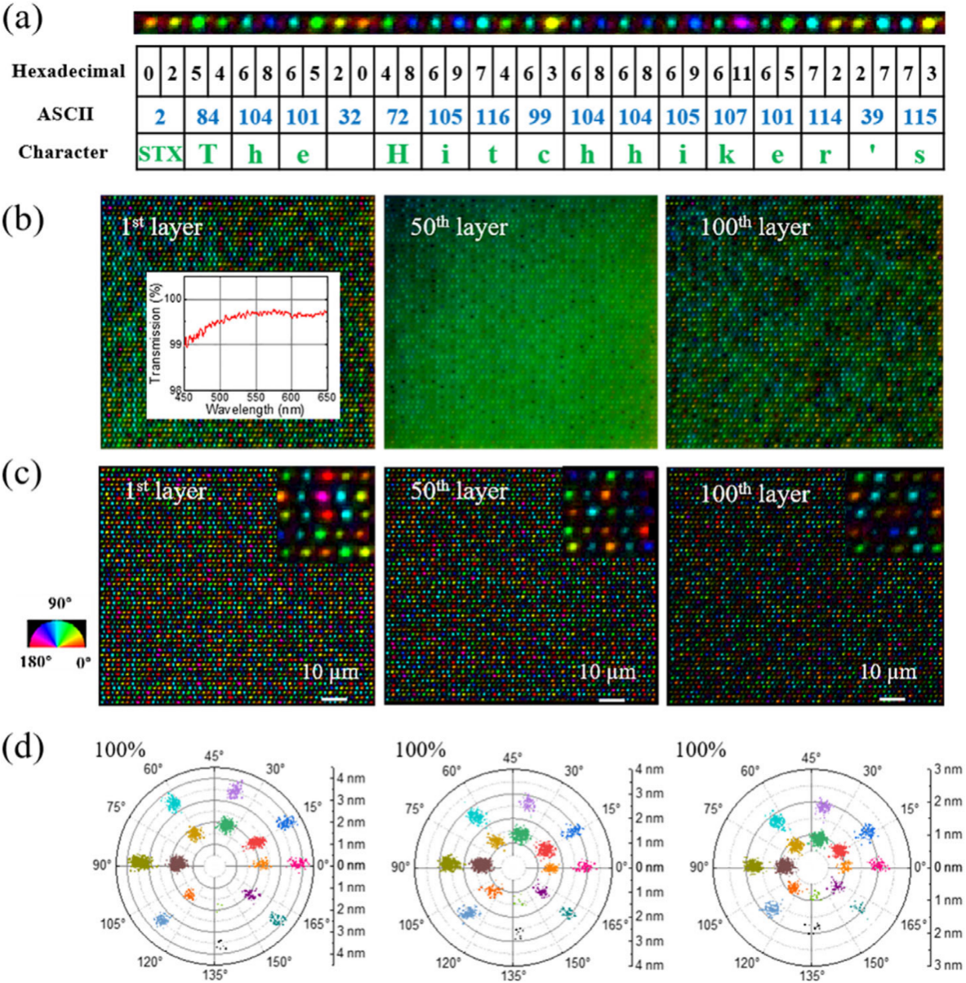
Figure 15. 5D storage of “The Hitchhiker’s Guide to the Galaxy.” (a) Illustration of data encoding and decoding. (b) Birefringent images of data voxels of different layers. Inset is the transmission of 100-layer data in the visible range. (c) Birefringent images after removing the background of (b). Insets are enlargements of small region (10 µm × 10 µm). (d) Polar diagram of the measured retardance and azimuth from all voxels in (c). Reproduced with permission from ref.^{[82]} Copyright 2022, John Wiley & Sons.

Despite all these progresses, the 5D optical data storage technique is yet in its early stage, and still stays at a lab stage. A great deal of explorations needs to be performed, and many practical problems need to be optimized and improved. Writing speed, data capacity and readout accuracy are still limited and the other two degrees of freedom (retardance and polarization azimuth angle) need to be improved. Overall, NGs open a new era for high performance, long lifetime and high-density optical data storage in the future.

2.6.2. Optical fibers-based sensors for harsh environment
With developing the optical industry, optical fibers and laser imprinted optical waveguides with various capabilities are increasingly well developed.^{[193-197]} In general, optical fibers can be classified on the basis of the different doping of chemical elements, F-/Ge-doped fiber being the most usual one. NGs, due to their unique anisotropic optical characteristics and very high thermal stability, can be mostly utilized in optical fiber-based sensors.^{[78,84]} Recently, Wei et al.^{[198]} investigated the thermal stability of NGs of fiber Bragg gratings (FBGs)^{[21,83,199-203]} under fs-laser irradiation, within various conventional glass systems, such as different Cl-/OH-doped silica glasses, GeO₂-SiO₂ binary glass and Ti-/B-doped commercial glasses. FBGs are very appealing and can be applied to temperature profiling of machinery in laser additive manufacturing,^{[204]} pressure and temperature monitoring in airplane engines and in the next generation sodium cooled nuclear reactors. The authors reported that higher Cl and OH contents can thoroughly eliminate thermal stability through the isochronal annealing experiments (Δt$\sim$30 min, ΔT$\sim$50 °C) up to 1400 °C. Besides, authors elucidated Ge-doped silica glass can exhibit higher optical retardance values (due to higher decomposition level and smaller pore size of GeO₂) and high thermal stability. This work provides a reference in the field of thermal stability of NGs in multicomponent silicate fibers. Intriguingly, in 2021 Wang et al.^{[205]} described a precision inscription of NGs within silica fiber cores in order to achieve sensors resistant to harsh environment. Low insertion loss (1 dB m⁻¹) and high thermal stability (tested at 1000 °C over 5 days) were demonstrated. Also, this sensor was detected in radiation circumstances in the Massachusetts Institute of Technology Nuclear Research Reactor (MITR). The paper presented NGs-based fiber sensors that were primary optical devices and applied to extreme environments. Recently, Wang et al.^{[22]} investigated the writing kinetics and thermal stability of laser-inscribed aligned nanostructures over a temperature range from 20 °C to 1200 °C in the cores of sapphire (Al₂O₃) and YAG derived silicate optical fibers, as in Figure 9a. The authors elucidated that optical sensors revealed high-temperature sensitivity and stability, e.g., the ones based on Rayleigh backscattering or FBG sensors, imprinted in these nonconventional fibers. They believed that this technique could be a promising large-scale platform for the next generation of harsh environment sensing optical devices.

2.6.3. Microfluidics
Thanks to the transient ultrahigh intensities of several TW/cm² of fs-laser, yielding to strong nonlinear light effect, the interior of transparent glasses can be modified in a spatially selective manner.^{[206]} By using this technique, optical waveguides can also be realized inside the transparent materials.^{[35,207]} Moreover, micro/nanofluidic channels can be produced by FLDW within transparent glasses, combined with wet chemical etching.^{[208,209]} Interestingly, in 2007 Osellame et al.^{[210]} demonstrated the integration of microfluidic channels and waveguides, under the irradiation of ultrafast laser, which indicates the excellent capability of ultrafast laser, as a single production tool, utilized for biophotonic sensors. Also, the authors’ other work upon the microfluidic channels has been highlighted.^{[211,212]} Currently, two main strategies are adopted for fabricating 3D microfluidic channels implanted in glasses: 1) using fs-laser to modify the inner of glass materials followed by chemical wet etching,^{[24,213,214]} but length of the microfluidic channel is generally limited to a few mms; or 2) performing fs-laser 3D drilling from the rear surface of glass in contact with distilled water.^{[215]} However, with the increase of channel length the detritus can no longer be ejected from the microchannel causing the blocking or termination of microchannel in case 2.
NGs, one type of the modifications induced by fs-laser in transparent solids, can be easily etched by strong acidic or basic solutions due to the nature of nanocavitations or to their oxygen deficient phases, meanwhile, the pristine areas keep unaffected. Based on this property, many applications, focused on microfluidics, have been developed. One of the main factors in microfluidics is the size of micro-channels, namely aspect ratio, which can directly affect the performance of microfluidic elements. In addition, in the field of micro-total analysis systems (µ-TASs) and biochip devices, in which micro-channels played a key role in the high-speed and efficient analysis of bio-chemical reagents,^{[216]} fs-laser micro-manufacturing can produce the microfluidics with low collateral damage, high precision accuracy and controllable aspect ratio due to strong nonlinear effect, compared to the photolithographic techniques.
In 2006, Hnatovsky et al.^{[24]} showed that highly different etching of the modified regions is correlated with the orientation of self-ordered nanocracks in 3D (linear polarization) and disordered nanostructures (circular polarization), which allow etchant to penetrate into the glass and etch micro-channels. This directly indicated that NGs played an important role in the processing of nano-channels with high aspect ratio. Interestingly, in 2011 Yu et al.^{[217]} further completed the investigation of the orientation of self-ordered nanolayers on etch rates and demonstrated the typical micro-channels of isosceles triangle and wavy structures written by fs-laser. The authors indicated the micro-channels induced by circular polarization (Figure 16b and d) revealed superior etch rates than that of linear polarization (Figure 16a and c) in arbitrary translating direction. Later, Liao et al.^{[218]} reported the fabrication of nanofluidic channels directly interred in silicate glass with transverse widths < 50 nm, by using 3D FLDW. The fabricated micro-nanofluidic systems have been used to demonstrate the analysis of DNA. This offers new opportunities to develop novel 3D micro/nanofluidic systems for multifunctional lab-on-a-chip applications. More recently, Lin et al.^{[219]} have demonstrated the blood vessel system inside a model hand based on microfluidics. Even if this strategy was not based on wet chemical etching of NGs, their study will be as well beneficial for the development of novel lab-on-a-chip and biochip devices towards finer understanding of human diseases as cancers, cardiovascular diseases etc. Also, their intriguing research makes us speculate if NGs could be utilized in this blood vessel system with higher resolution and lower roughness. In any case, still several aspects are needed to be improved, like the decrease of roughness of the inner walls of micro-channels or the increase of surface smoothness of the printed glass.

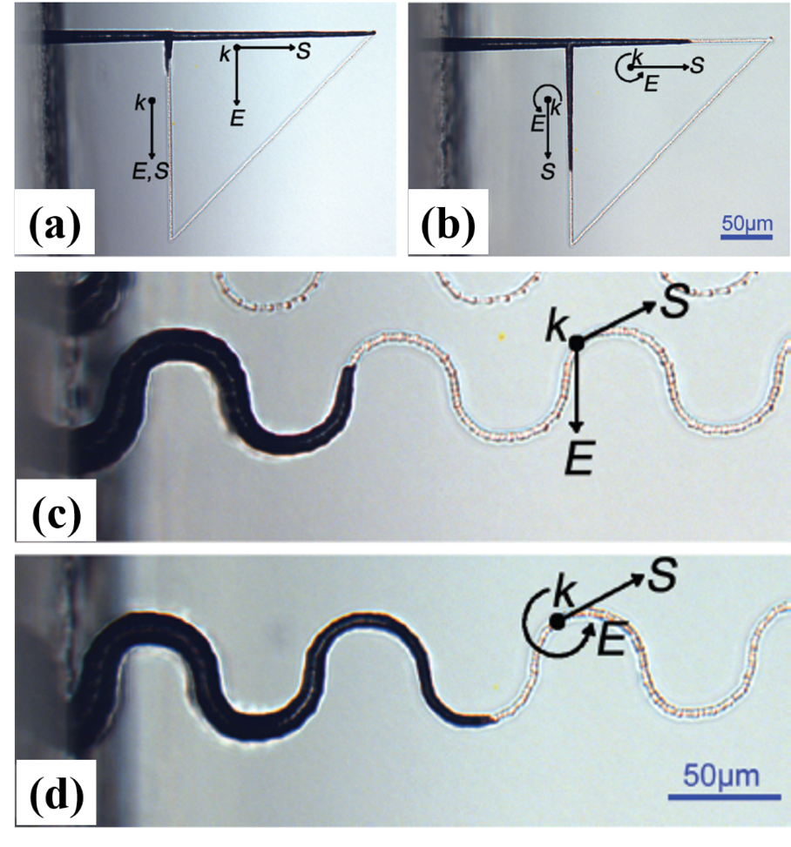
Figure 16. Optical micrographs of micro-channels of identical isosceles triangle structures induced by (a) linear and (b) circular laser polarization states. (c) and (d) present optical micrographs of wavy structure micro-channels at linear and circular polarization, respectively. Reproduced with permission from ref.^{[217]} Copyright 2011, American Institute of Physics.

Overall, these important progresses indicate the developed direction of microfluidics and open a novel approach for the production of photonic components including optical waveguides, and microelectric components in the 3D laser-manufactured microfluidic systems.

2.6.4. Micro-optical elements, space variant birefringent and 3D geometric phase optics
NGs, as an embedded nanoscale structure, possess many unique properties leading to different targeted photonic applications in recent years. One of the host characteristics of NGs is the polarization-dependent negative uniaxial birefringence due to the nature of alternating periodic arrangement of nanolayers with two different refractive indices (n₁ and n₂).^{[77,220]} Based on the produced retardance and subsequent birefringence, 2D and 3D space variant birefringent devices, 3D geometric phase optics^{[221]} for flat optics (prisms, lenses, gratings), and 3D beam shaping optics to control locally phase amplitude and polarization across the laser beam cross-section and even along the propagation, can be made.
Birefringent devices: Ramirez et al.^{[158]} reported a NGs-based waveplate under certain parameters which decreased the processing time to 45 min for a single layer area of 1 mm² yielding to a retardance of $π$/4 under wavelength of 633 nm in SiO₂. Therefore, the birefringent elements were able to be imprinted by fs-laser with various precise retardances. Lancry et al.,^{[74]} in 2014, have also achieved multilayers writing birefringent waveplates with a total retardance higher than 1600 nm using only 5 layers in silica by fs-laser, as shown in Figure 17. They confirmed the successful realization of a very high retardance of $\sim$350 nm at the wavelength $λ$ of 546 nm while maintaining the calculated birefringence constant ($≈$7 $×$ 10⁻³) under the parameters of 1030 nm, 300 fs, 0.6 NA, 100 kHz, 100 μm/s and 2.5 μJ/pulse; this was the highest reported optical phase retardance value in the literature using FLDW. Later, in 2020, Tian et al.^{[105]} additionally reported stress-engineered waveplates originating from NGs written by fs-laser in silica. Here, several twin columns of lines (defined as “stress bar” composed of 10 layers in Z-axis) were created along with stress bar spacing 1 mm defining a 1 mm $×$ 1 mm clear aperture. Indeed, a high retardance of 450 nm (a half waveplate) for this stress-engineered waveplate was detected free from laser direct modifications and with negligible excess losses (< 1 cm⁻¹ from 200 to 1700 nm) in the clear aperture, compared to the NGs-based waveplate. This opened the door for the implementation of innovative and versatile waveplates, and hence the integration of optical components.

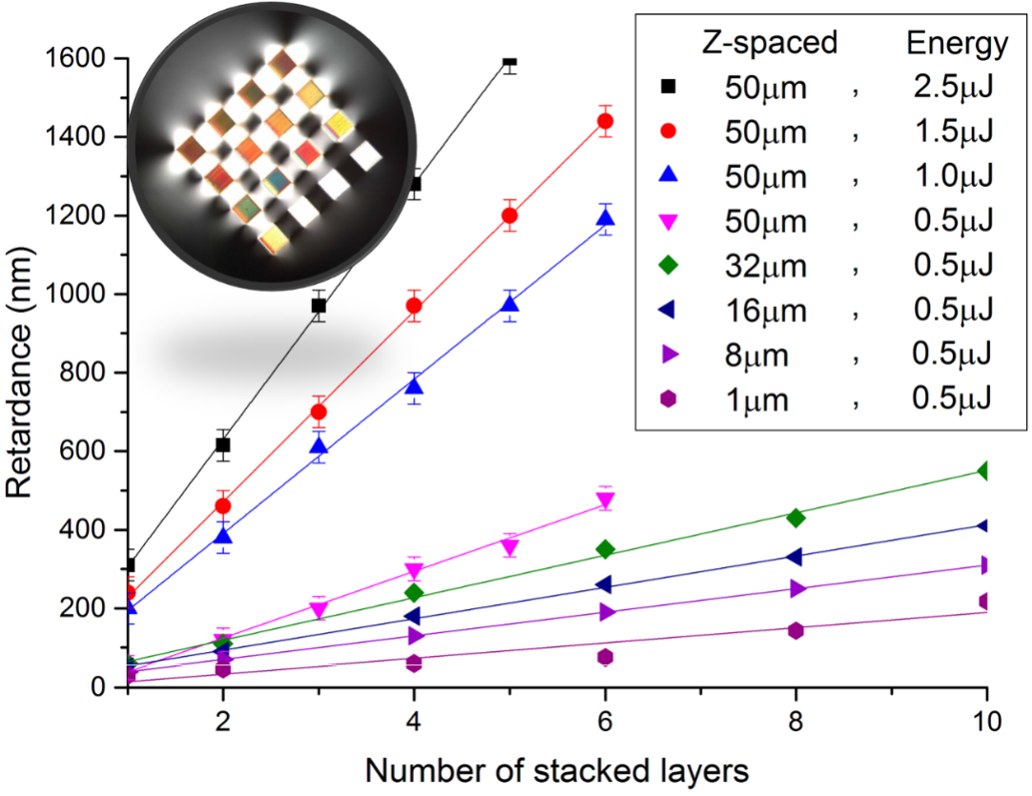
Figure 17. Retardance as a function of the number of stacked layers and their Z-spacing (spacing between consecutive layers in the propagation direction) for a variety of pulse energies. The inset is the optical graph of retardance with varying stacked layers. Reproduced with permission from ref.^{[74]} Copyright 2014, MDPI.

3D geometric phase optics: The advances recently achieved in flat optics break through the limitations of conventional optics, i.e., manipulating light waves by implementing ultra-thin planar components instead of relying on optical path differences. In principle, the phase profiles of nearly any optical components, such as lenses, vortex phase plates, or elements, enabling light to bend in peculiar ways could be designed on the basis of gradient metasurfaces, known as geometric-phase (Pancharatnam-Berry phase) optical components. In addition, geometric-phase optics can theoretically achieve any phase profile with high efficiencies and transparency. Following this view, the light phase that is tuned by geometric phase optics (i.e. anisotropic media) is of great interest in designing functional devices integrated into the systems including high-resolution microscopy, optical communication systems, and consumer electronics. Indeed NGs, induced by fs-laser, can be utilized as geometric phase regulators, due to the features of tunable slow-axis azimuth and the related optical retardance. As far back as 2002, Bricchi et al. ^{[222]} demonstrated strongly birefringent Fresnel zone plates imprinted in silica glasses, which are attractive due to their unique focusing abilities and compactness. Besides, in 2014, Gecevičius et al.^{[223]} fabricated Airy beam^{[224]} converters based on space variant birefringent structures induced by fs-laser and demonstrated a spontaneous “self-detachment” of a fiber-like structure in their study, by using this converter, enabling the fabrication of glass cantilevers in a substitute way. Intuitively, in 2015, Drevinskas et al.^{[61]} demonstrated a 3D sketch of laser-induced NG structures by an ideal cube shape with a constantly ordered assembly along the entire depth, where the optical axis is parallel to the direction of laser polarization and the slow axis is perpendicular to the polarization orientation. In 2015, the spin-dependent deflection based on twisted NGs was firstly demonstrated.^{[225]} Also, in 2017,^{[28]} Drevinskas et al. have successfully imprinted the high-performance geometric phase components^{[226]} in silica glass by ultrafast laser direct writing, which implied the potential of NGs applied in high-resolution microscopy, polarization sensitive imaging,^{[227]} high-power lasers and optical communication systems. Also, the printing of multi-sheet optical elements inside silica glass and fiber with the essential advantage of low transmission losses (< 4% at wavelength 1064 nm),^{[28]} high efficiency and high thermal/chemical stability makes the portable instruments possible for a great deal of practical applications such as integrated miniature illumination, detection systems and endoscopes.
Fiber-based devices: Besides, optical fibers have attracted the wide attention of the researchers since their first fabrication. Based on the broadband optical spectrum and the strong demand on wider IR region, IR optical fibers have been mainly used for the transmission of light energy. Indeed, both the transparency in the mid-IR range (3-5 µm) and the higher nonlinear refractive index of GeO₂-based glasses, compared to fused silica, make them a natural candidate for many applications in the near-/mid-IR region.^{[228,229]} Dai et al.^{[25]} reported the fabrication and characterization of fiber NGs (FNGs) induced by FLDW, as shown in Figure 18. The principle of birefringence characterization is given by I ∝ $\sin^{2}(\frac{π∙∆∙L}{λ})$, where I is the optical intensity of light transmission, Δ is the value of birefringence, and the parameters L and λ are the length of the NG along the illuminated light propagation direction and the corresponding wavelength, respectively. Ge-doping plays an important role during the formation of NGs in optical fibers because Ge-doped core material presents a lower bandgap compared to the undoped silica glass in the fiber cladding, resulting in a larger ionized region in the fiber core and thus larger NG size. In addition, a strong birefringence and a negative refractive index distribution with sawtooth structure of NGs were highlighted. Also, the in-line has been achieved in a broadband spectrum range (1300 up to 1600 nm) and the method for improving the extinction ratio of the polarizer has been discussed indicating NGs could reveal various and promising applications in most fiber-optic systems. Here the extinction ratio (i.e., the maximum to minimum transmitted intensity ratio) in terms of dB is defined as follows:
$ER\left(dB\right)=10log\left(\frac{I_{max}}{I_{min}}\right)= I_{max}\left(dB\right)- I_{min}(dB)$ (6)

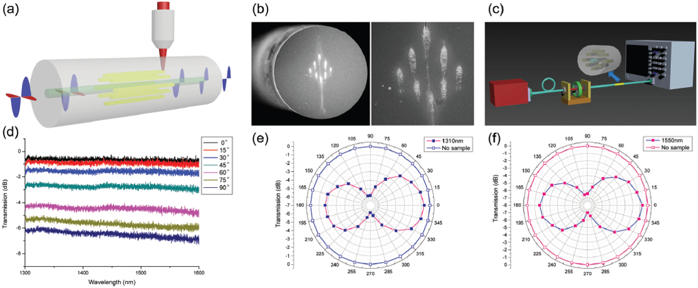
Figure 18. (a) Schematic diagram of in-line fiber polarizer based on NGs. (b) SEM images of the fiber end-face with NGs embedded around fiber core. (c) Schematic of the in-line polarizer testing set-up. (d) Loss spectra at varying input polarization angles. Polarization distribution of the in-line fiber polarizer (■) and a bare fiber (□) at the wavelength of 1310 nm (e) and 1550 nm (f). Reproduced with permission from ref.^{[25]} Copyright 2018, Royal Society of Chemistry.

Example of micro-optics for mid-IR: Most recently, Yao et al.^{[41]} demonstrated a single-step birefringent Fresnel zone plate (one of the 3D geometric phase optics) with a 2 mm outer diameter imprinted in the 8 mol% Ta₂O₅-BGG glass (a mid-IR glass). This Fresnel graded-index (GRIN) plate was a gradient thickness lens with superimposing layers of uniform index changes in the glass. Here, 4 laser-induced layers were imprinted in the glass with 50 μm spacing between each layer. Indeed, the Fresnel GRIN plate was fabricated under the laser conditions of 1.6 μJ, 800 fs and 0.1 mm/s in order to reach a $π$/2 phase retardance, i.e., a maximum of 2$π$, at the designed wavelength. This fabrication process took nearly 5 h for inscribing the Fresnel GRIN plate. Here the authors mainly measured the primary focus at 632 nm and the experimental waist along the defocus distance, and then revealed the theoretical and experimental results of beam size measured at a cutoff intensity value of 1/e² were in good agreement, with only 6% deviation, as in Figure 19a. Moreover, as shown in Figure 19b, the strong birefringence could be observed in the odd zones of embedded Fresnel zone plate. Figure 19c presents the typical primary focal spot. This work proved the prime potential of BGG glass in the field of NGs for practical applications.

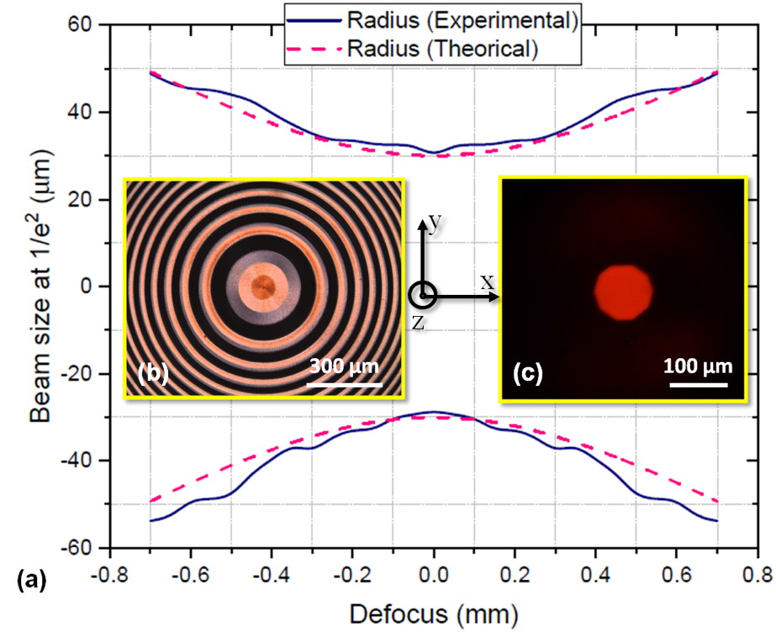
Figure 19. (a) Beam size at 1/e² ($μ$m) vs. defocus (mm) with experimental and theoretical radius values. (b) Microscope image of laser-inscribed Fresnel zone plate. (c) Image of the primary focus at 632 nm in the 8 mol% Ta₂O₅-BGG glass sample. Reproduced with permission from ref.^{[41]} Copyright 2022, Elsevier.

Many others micro-optical elements, including other 3D geometric phase optics (Airy beam convertors,^{[223]} or polarization-shaped Bessel beam,^{[98]} polarization diffraction focusing lens and Q-plate^{[221]}, chiral waveplates^{[96]}) and space variant birefringence devices (“S” waveplate^{[26]}, achromatic polarization rotator,^{[230]} and polarization diffractive grating (PDG)^{[231]} which can convert polarization^{[232]} and split the beam^{[233,234]}), have also been reported in the literature.

3. Conclusion and Outlook

In this paper, the improvement in the field of ultrafast laser-induced Type II transformations (so-called-NGs) from the initial experimental discovery to the industrial and laboratorial applications, has been thoroughly reviewed. The focus has been devoted on the discovery process, the characteristics, properties and parameter dependencies of NGs, the modelling mechanism of NGs formation, and the NGs-based optical applications. From its first direct observation in 2003, these have attracted the strong attention in the scientific world. In addition, their unique formation mechanisms (nonlinear optics, plasma and related thermodynamics) and properties that NGs display, from form birefringence and polarization dependent anisotropy to thermal stability and optical chirality, show more practical significance. More specifically, how to control the NGs formation and subsequently the resulting properties? Consequently, parameter dependencies of NGs formation from conventional laser parameters (like pulse energy, speed) to non-conventional parameter conditions (like PFT), material chemical composition have been discussed. After introducing the inner structures, properties and tunable parameters of NGs, the related formation mechanism of NGs, from plasmon-photon interference to self-trapped excitons, persistently a hotspot, has been discussed, even though it is still under debate. Finally, all the theoretical studies serve for the practical use. The optical applications based on NGs from 5D optical memory to micro-optical elements have been demonstrated. Kazansky’s group has achieved high-density 5D optical data storage with ultra-long lifetime at room T on the basis of early birth structures of NGs, i.e. Type X. Based on their extraordinary thermal stability, relevant optical sensors for harsh environments are realized. In addition, micro/nano-fluidic channels and micro-mechanical sensors can also be performed due to the selective chemical etching of NGs. A series of optical elements upon the feature of NGs tuning optical phase are, as well, presented, like space variant birefringent waveplates, chiral waveplates or 3D geometric phase components.
Throughout the two decades of NGs development, from conventional materials like SiO₂ to various transparent materials (crystals or multicomponent glasses), from plasmon-photon interference to inhomogeneity-scattered waves interference or nanocavitation mechanisms, from birefringent Fresnel zone plates to current 5D optical data storage or fiber sensors, and from conventional parameters dependencies to the non-conventional ones, significant progresses have been conducted in this field. NGs, originating from light-matter interaction in which “light” has mostly been investigated, could thus further be focused on the study of “matter” which not only represents the various materials (like Fluoride or Chalcogenide glasses) but also means the mechanisms of NGs (like plasma-mediated nanocavitation, electrochemical force and inhomogeneity-scattered waves interference).
To deeper investigate the structural changes and mechanisms of NGs, nanoscale techniques such as nanoIR and nanoRaman can be utilized. The investigations of structural changes at 10 nm scale can be performed by using vibrational spectroscopy, nano X-ray photoelectron emission microscopy (XPEEM), and elemental analysis can be conducted by using HR-TEM Electron Energy Loss Spectroscopy (EELS), EFM to check the presence of space charge field specifically at short time scales (ps-ns). From an engineering point of view, temporal shaping such as few pulses and GHz burst machining can be applied for enhancing NGs lineic writing speed combined to the control of nm scale porosity in glasses which favors NGs formation, while spatial shaping such as extended focus, multi foci etc. can be used for enhancing volumetric writing speed. Combination with spatial pulse shaping (e.g. truncated Airy or truncated Bessel beams) could result in the enhancement of spatial uniformity of NGs and the reduction of overall optical losses. In addition, the development of few-cycles ultrafast pulses processing may result in an “avalanche-free” mode for a more efficient and highly localized energy deposition, a more efficient manipulation of spatio-temporal coupling and a better control of NGs seeding process.

Conflict of Interest

The authors declare no conflicts of interest.

Acknowledgements

We are grateful for financial supports from National Natural Science Foundation of China (12274280, 11774220); Agence Nationale de la Recherche (ANR-18-CE08-0004-01, FLAG-IR Project); Science and Technology Innovation Plan of Shanghai Science and Technology Commission (20JC1415700); The China Scholarship Council (CSC) Project (No. 202206890050). We greatly acknowledge Professor Juan Song of Jiangsu University for valuable discussions.

Received: (())
Revised: (())
Published online: (())

References
[1] B. Zhang, D. Tan, Z. Wang, X. Liu, B. Xu, M. Gu, L. Tong, J. Qiu, Light Sci. Appl. 2021, 10, 93.
[2] Q. Xie, M. Cavillon, D. Pugliese, D. Janner, B. Poumellec, M. Lancry, Nanomaterials 2022, 12, 2986.
[3] M. Lancry, B. Poumellec, A. C. Erraji, M. Beresna, P. G. Kazansky, Opt. Mater. Express 2011, 1, 711.
[4] M. Lancry, J. Canning, K. Cook, M. Heili, D. R. Neuville, B. Poumellec, Opt. Mater. Express 2016, 6, 321.
[5] F. Han, S. Gu, A. Klimas, N. Zhao, Y. Zhao, S. C. Chen, Science 2022, 378, 1325.
[6] X. Xu, T. Wang, P. Chen, C. Zhou, J. Ma, D. Wei, H. Wang, B. Niu, X. Fang, D. Wu, S. Zhu, M. Gu, M. Xiao, Y. Zhang, Nature 2022, 609, 496.
[7] D. Wei, C. Wang, H. Wang, X. Hu, D. Wei, X. Fang, Y. Zhang, D. Wu, Y. Hu, J. Li, S. Zhu, M. Xiao, Nat. Photonics 2018, 12, 596.
[8] Z. Wang, B. Zhang, Z. Wang, J. Zhang, P. G. Kazansky, D. Tan, J. Qiu, Adv. Mater. 2023, 35, 2303256.
[9] B. Zhang, Z. Wang, D. Tan, J. Qiu, PhotoniX 2023, 4, 24.
[10] Q. Geng, D. Wang, P. Chen, S. -C. Chen, Nat. Communications 2019, 10, 2179.
[11] H. Wang, W. Zhang, D. Ladika, H. Yu, D. Gailevičius, H. Wang, C. F. Pan, P. N. S. Nair, Y. Ke, T. Mori, J. Y. E. Chan, Q. Ruan, M. Farsari, M. Malinauskas, S. Juodkazis, M. Gu, J. K. W. Yang, Adv. Funct. Mater. 2023, 33, 2214211.
[12] K. M. Davis, K. Miura, N. Sugimoto, K. Hirao, Opt. Lett. 1996, 21, 1729.
[13] Y. Shimotsuma, P. G. Kazansky, J. Qiu, K. Hirao, Phys. Rev. Lett. 2003, 91, 247405.
[14] E. N. Glezer, E. Mazur, Appl. Phys. Lett. 1997, 71, 882.
[15] B. Poumellec, M. Lancry, A. C. Erraji, P. G. Kazansky, Opt. Mater. Express 2011, 1, 766.
[16] J. W. Chan, T. R. Huser, S. H. Risbud, D. M. Krol, Appl. Phys. A 2003, 76, 367.
[17] M. Lancry, B. Poumellec, Phys. Rep. 2013, 523, 207.
[18] E. Bricchi, B. G. Klappauf, P. G. Kazansky, Opt. Lett. 2004, 29, 119.
[19] J. Zhang, M. Gecevičius, M. Beresna, P. G. Kazansky, Phys. Rev. Lett. 2014, 112, 033901.
[20] A. Rowstron, in Advanced Photonics 2018 (BGPP, IPR, NP, NOMA, Sensors, Networks, SPPCom, SOF), Optica Publishing Group, Washington, USA 2018, paper NeM4F.2.
[21] S. J. Mihailov, D. Grobnic, C. Hnatovsky, R. B. Walker, P. Lu, D. Coulas, H. Ding, Sensors 2017, 17, 2909.
[22] Y. Wang, M. Cavillon, J. Ballato, T. Hawkins, T. Elsmann, M. Rothhardt, R. Desmarchelier, G. Laffont, B. Poumellec, M. Lancry, Adv. Opt. Mater. 2022, 10, 2200379.
[23] Y. Bellouard, A. Said, M. Dugan, P. Bado, Opt. Express 2004, 12, 2120.
[24] C. Hnatovsky, R. S. Taylor, E. Simova, P. P. Rajeev, D. M. Rayner, V. R. Bhardwaj, P. B. Corkum, Appl. Phys. A 2006, 84, 47.
[25] J. Lu, Y. Dai, Q. Li, Y. Zhang, C. Wang, F. Pang, T. Wang, X. Zeng, Nanoscale 2019, 11, 908.
[26] M. Beresna, M. Gecevičius, P. G. Kazansky, T. Gertus, Appl. Phys. Lett. 2011, 98, 201101.
[27] M. Beresna, M. Gecevičius, P. G. Kazansky, Adv. Opt. Photonics 2014, 6, 293.
[28] R. Drevinskas, P. G. Kazansky, APL Photonics 2017, 2, 066104.
[29] R. L. Fleischer, P. B. Price, R. M. Walker, Annu. Rev. Nucl. Sci. 1965, 15, 1.
[30] M. Lancry, B. Poumellec, J. Canning, K. Cook, J. -C. Poulin, F. Brisset, Laser Photonics Rev. 2013, 7, 953.
[31] S. Juodkazis, K. Nishimura, S. Tanaka, H. Misawa, E. G. Gamaly, B. L. Davies, L. Hallo, P. Nicolai, V. T. Tikhonchuk, Phys. Rev. Lett. 2006, 96, 166101.
[32] R. Stoian, K. Mishchik, G. Cheng, C. Mauclair, C. D’Amico, J. P. Colombier, M. Zamfirescu, Opt. Mater. Express 2013, 3, 1755.
[33] S. Juodkazis, H. Misawa, T. Hashimoto, E. G. Gamaly, B. L. Davies, Appl. Phys. Lett. 2006, 88, 201909.
[34] A. M. Blondin, J. Bonse, A. Rosenfeld, I. V. Hertel, Y. P. Meshcheryakov, N. M. Bulgakova, E. Audouard, R. Stoian, Appl. Phys. Lett. 2009, 94, 041911.
[35] H. Yao, R. Zaiter, M. Cavillon, B. Sapaly, F. Calzavara, P. Delullier, T. Cardinal, Y. Dai, B. Poumellec, M. Lancry, Ceram. Int. 2021, 47, 34235.
[36] H. S. Carslaw, J. C. Jaeger, Conduction of Heat in Solids, Clarendon Press, Oxford, UK 1959.
[37] R. Que, M. Lancry, B. Poumellec, Micromachines 2024, 15, 196.
[38] C. B. Schaffer, J. F. García, E. Mazur, Appl. Phys. A 2003, 76, 351.
[39] S. M. Eaton, H. Zhang, P. R. Herman, F. Yoshino, L. Shah, J. Bovatsek, A. Y. Arai, Opt. Express 2005, 13, 4708.
[40] Y. Dai, B. Zhu, J. Qiu, H. Ma, B. Lu, S. Cao, B. Yu, Appl. Phys. Lett. 2007, 90, 181109.
[41] H. Yao, R. Zaiter, M. Cavillon, P. Delullier, B. Lu, T. Cardinal, Y. Dai, B. Poumellec, M. Lancry, Ceram. Int. 2022, 48, 31363.
[42] M. Birnbaum, J. Appl. Phys. 1965, 36, 3688.
[43] J. Bonse, J. Krüger, S. Höhm, A. Rosenfeld, J. Laser Appl. 2012, 24, 042006.
[44] Z. Guosheng, P. M. Fauchet, A. E. Siegman, Phys. Rev. B 1982, 26, 5366.
[45] H. M. V. Driel, J. E. Sipe, J. F. Young, Phys. Rev. Lett. 1982, 49, 1955.
[46] R. J. Nemanich, D. K. Biegelsen, W. G. Hawkins, Phys. Rev. B 1983, 27, 7817.
[47] J. Bonse, S. Baudach, J. Krüger, W. Kautek, M. Lenzner, Appl. Phys. A 2002, 74, 19.
[48] A. Siegman, P. M. Fauchet, IEEE J. Quantum Electron. 1986, 22, 1384.
[49] A. Borowiec, H. K. Haugen, Appl. Phys. Lett. 2003, 82, 4462.
[50] N. Yasumaru, K. Miyazaki, J. Kiuchi, Appl. Phys. A 2003, 76, 983.
[51] B. Gaković, M. Trtica, D. Batani, T. Desai, P. Panjan, D. Vasiljević-Radović, J. Opt. A: Pure Appl. Opt. 2007, 9, S76.
[52] J. Bonse, A. Rosenfeld, J. Krüger, J. Appl. Phys. 2009, 106, 104910.
[53] J. Bonse, S. Hohm, S. V. Kirner, A. Rosenfeld, J. Kruger, IEEE J. Sel. Top. Quantum Electron. 2016, 23, 1.
[54] R. Buividas, M. Mikutis, S. Juodkazis, Prog. Quantum Electron. 2014, 38, 119.
[55] J. Bonse, M. Munz, H. Sturm, J. Appl. Phys. 2005, 97, 013538.
[56] J. Bonse, J. Krüger, J. Appl. Phys. 2010, 108, 034903.
[57] S. K. Sundaram, E. Mazur, Nat. Mater. 2002, 1, 217.
[58] L. Sudrie, M. Franco, B. Prade, A. Mysyrowicz, Opt. Commun. 1999, 171, 279.
[59] P. G. Kazansky, H. Inouye, T. Mitsuyu, K. Miura, J. Qiu, K. Hirao, F. Starrost, Phys. Rev. Lett. 1999, 82, 2199.
[60] J. Qiu, P. G. Kazansky, J. Si, K. Miura, T. Mitsuyu, K. Hirao, A. L. Gaeta, Appl. Phys. Lett. 2000, 77, 1940.
[61] R. Drevinskas, M. Gecevicius, M. Beresna, Y. Bellouard, P. G. Kazansky, Opt. Express 2015, 23, 1428.
[62] R. S. Taylor, C. Hnatovsky, E. Simova, Laser Photonics Rev. 2008, 2, 26.
[63] B. Poumellec, L. Sudrie, M. Franco, B. Prade, A. Mysyrowicz, Opt. Express 2003, 11, 1070.
[64] Y. Bellouard, E. Barthel, A. A. Said, M. Dugan, P. Bado, Opt. Express 2008, 16, 19520.
[65] J. Canning, M. Lancry, K. Cook, A. Weickman, F. Brisset, B. Poumellec, Opt. Mater. Express 2011, 1, 998.
[66] C. M. Pépin, E. Block, R. Gaal, J. Nillon, C. Hoenninger, P. Gillet, Y. Bellouard, arXiv:1806.10802, submitted: 28 Jun, 2018,
[67] F. Zimmermann, Ultrashort Pulse Induced Nanostructures in Transparent Materials, Friedrich-Schiller-Universität Jena, March, 2017.
[68] L. Skuja, B. Güttler, Phys. Rev. Lett. 1996, 77, 2093.
[69] A. J. Berger, Y. Wang, D. M. Sammeth, I. Itzkan, K. Kneipp, M. S. Feld, Appl. Spectrosc. 1995, 49, 1164.
[70] Y. Bellouard, A. Champion, B. McMillen, S. Mukherjee, R. R. Thomson, C. Pépin, P. Gillet, Y. Cheng, Optica 2016, 3, 1285.
[71] A. Champion, Y. Bellouard, Opt. Mater. Express 2012, 2, 789.
[72] S. Richter, A. Plech, M. Steinert, M. Heinrich, S. Döring, F. Zimmermann, U. Peschel, E. B. Kley, A. Tünnermann, S. Nolte, Laser Photonics Rev. 2012, 6, 787.
[73] Q. Xie, N. Shchedrina, M. Cavillon, B. Poumellec, M. Lancry, Nanoscale Adv. 2024, 6, 489.
[74] M. Lancry, R. Desmarchelier, K. Cook, B. Poumellec, J. Canning, Micromachines 2014, 5, 825.
[75] Y. Shimotsuma, T. Sei, M. Sakakura, K. Miura, H. Udono, J. Laser Micro/Nanoeng. 2016, 11, 35.
[76] M. Born, E. Wolf, Principles of Optics: Electromagnetic Theory of Propagation, Interference and Diffraction of Light, Elsevier Ltd., Amsterdam 1980.
[77] R. Desmarchelier, B. Poumellec, F. Brisset, S. Mazerat, M. Lancry, World J. Nano Sci. Eng. 2015, 5, 115.
[78] E. Bricchi, P. G. Kazansky, Appl. Phys. Lett. 2006, 88, 111119.
[79] F. Zhang, Y. Yu, C. Cheng, Y. Dai, J. Qiu, Opt. Lett. 2013, 38, 2212.
[80] Y. Dai, G. Wu, X. Lin, G. Ma, J. Qiu, Opt. Express 2012, 20, 18072.
[81] M. Beresna, M. Gecevičius, M. Lancry, B. Poumellec, P. G. Kazansky, Appl. Phys. Lett. 2013, 103, 131903.
[82] H. Wang, Y. Lei, L. Wang, M. Sakakura, Y. Yu, G. Shayeganrad, P. G. Kazansky, Laser Photonics Rev. 2022, 16, 2100563.
[83] M. A. S. Zaghloul, M. Wang, S. Huang, C. Hnatovsky, D. Grobnic, S. Mihailov, M. J. Li, D. Carpenter, L. W. Hu, J. Daw, G. Laffont, S. Nehr, K. P. Chen, Opt. Express 2018, 26, 11775.
[84] D. Grobnic, C. W. Smelser, S. J. Mihailov, R. B. Walker, Meas. Sci. Technol. 2006, 17, 1009.
[85] Eternal 5D data storage could record the history of humankind, https://www.southampton.ac.uk/news/2016/02/5d-data-storage-update.page, accessed: September, 2023.
[86] Y. Wang, M. Lancry, M. Cavillon, B. Poumellec, Opt. Lett. 2022, 47, 1242.
[87] H. Yao, Q. Xie, M. Cavillon, Y. Dai, M. Lancry, Prog. Mater Sci. 2024, 142, 101226.
[88] Q. Xie, M. Cavillon, B. Poumellec, M. Lancry, Appl. Opt. 2023, 62, 6794.
[89] P. G. Kazansky, W. Yang, E. Bricchi, J. Bovatsek, A. Arai, Y. Shimotsuma, K. Miura, K. Hirao, Appl. Phys. Lett. 2007, 90, 151120.
[90] B. Poumellec, M. Lancry, J. -C. Poulin, S. Ani-Joseph, Opt. Express 2008, 16, 18354.
[91] M. Lancry, B. Poumellec, R. Desmarchelier, B. Bourguignon, Opt. Mater. Express 2012, 2, 1809.
[92] P. Curie, Journal de Physique Théorique et Appliquée 1894, 3, 393.
[93] R. S. Taylor, E. Simova, C. Hnatovsky, Opt. Lett. 2008, 33, 1312.
[94] B. Poumellec, M. Lancry, R. Desmarchelier, E. Herve, B. Bourguignon, Light Sci. Appl. 2016, 5, e16178.
[95] J. Lu, J. Tian, B. Poumellec, E. Garcia-Caurel, R. Ossikovski, X. Zeng, M. Lancry, Light Sci. Appl. 2023, 12, 46.
[96] J. Lu, E. Garcia-Caurel, R. Ossikovski, F. Courvoisier, X. Zeng, B. Poumellec, M. Lancry, Opt. Lett. 2023, 48, 271.
[97] J. Lu, M. Hassan, F. Courvoisier, E. Garcia-Caurel, F. Brisset, R. Ossikovski, X. Zeng, B. Poumellec, M. Lancry, APL Photonics 2023, 8, 060801.
[98] M. Hassan, J. Lu, B. Sapaly, M. Lancry, F. Courvoisier, Proc. SPIE 2022, PC12142, PC1214209.
[99] R. S. Taylor, C. Hnatovsky, E. Simova, P. P. Rajeev, D. M. Rayner, P. B. Corkum, Opt. Lett. 2007, 32, 2888.
[100] W. Zhang, Q. Zhai, J. Song, K. Lou, Y. Li, Z. Ou, Q. Zhao, Y. Dai, J. Phys. D Appl. Phys. 2020, 53, 165106.
[101] C. Hnatovsky, R. S. Taylor, P. P. Rajeev, E. Simova, V. R. Bhardwaj, D. M. Rayner, P. B. Corkum, Appl. Phys. Lett. 2005, 87, 014104.
[102] A. Rudenko, J. -P. Colombier, T. E. Itina, Phys. Chem. Chem. Phys. 2018, 20, 5887.
[103] F. Zimmermann, M. Lancry, A. Plech, S. Richter, T. Ullsperger, B. Poumellec, A. Tünnermann, S. Nolte, Int. J. Appl. Glass Sci. 2016, 8, 233.
[104] D. Tan, K. N. Sharafudeen, Y. Yue, J. Qiu, Prog. Mater Sci. 2016, 76, 154.
[105] J. Tian, H. Yao, M. Cavillon, E. Garcia-Caurel, R. Ossikovski, M. Stchakovsky, C. Eypert, B. Poumellec, M. Lancry, Micromachines 2020, 11, 131.
[106] F. Zhang, A. Cerkauskaite, R. Drevinskas, P. G. Kazansky, J. Qiu, Adv. Opt. Mater. 2017, 5, 1700342.
[107] D. N. Vitek, E. Block, Y. Bellouard, D. E. Adams, S. Backus, D. Kleinfeld, C. G. Durfee, J. A. Squier, Opt. Express 2010, 18, 24673.
[108] R. Kammel, R. Ackermann, J. Thomas, J. Götte, S. Skupin, A. Tünnermann, S. Nolte, Light Sci. Appl. 2014, 3, e169.
[109] Y. Lei, H. Wang, G. Shayeganrad, Y. Svirko, P. G. Kazansky, ArXiv preprint:2401.09055, submitted: 17 Jan, 2024,
[110] Q. Yao, J. Song, W. Yin, H. Shi, H. Yao, Z. Su, Y. Dai, J. Phys. D Appl. Phys. 2023, 56, 265101.
[111] M. Lancry, F. Zimmerman, R. Desmarchelier, J. Tian, F. Brisset, S. Nolte, B. Poumellec, Appl. Phys. B 2016, 122, 66.
[112] B. Zhang, X. Liu, J. Qiu, J. Materiomics 2019, 5, 1.
[113] H. Yao, Q. Xie, M. Cavillon, D. R. Neuville, D. Pugliese, D. Janner, Y. Dai, B. Poumellec, M. Lancry, Opt. Express 2023, 31, 15449.
[114] C. Mauclair, M. Zamfirescu, J. -P. Colombier, G. Cheng, K. Mishchik, E. Audouard, R. Stoian, Opt. Express 2012, 20, 12997.
[115] B. Zhang, Z. Wang, D. Tan, X. Liu, B. Xu, L. Tong, P. G. Kazansky, J. Qiu, Adv. Opt. Mater. 2021, 9, 2001962.
[116] B. Zhang, D. Tan, X. Liu, L. Tong, P. G. Kazansky, J. Qiu, Adv. Opt. Mater. 2019, 7, 1900593.
[117] S. Richter, M. Heinrich, S. Döring, A. Tünnermann, S. Nolte, U. Peschel, J. Laser Appl. 2012, 24, 042008.
[118] M. Gecevičius, M. Beresna, J. Zhang, W. Yang, H. Takebe, P. G. Kazansky, Opt. Express 2013, 21, 3959.
[119] K. Sugioka, Int. J. Extreme Manuf. 2021, 3, 043001.
[120] V. R. Bhardwaj, E. Simova, P. P. Rajeev, C. Hnatovsky, R. S. Taylor, D. M. Rayner, P. B. Corkum, Phys. Rev. Lett. 2006, 96, 057404.
[121] A. Dostovalov, S. Babin, M. Dubov, M. Baregheh, V. Mezentsev, Laser Phys. 2012, 22, 930.
[122] M. Sakakura, Y. Lei, L. Wang, Y. H. Yu, P. G. Kazansky, Light Sci. Appl. 2020, 9, 15.
[123] D. Wortmann, M. Ramme, J. Gottmann, Opt. Express 2007, 15, 10149.
[124] S. Richter, F. Jia, M. Heinrich, S. Döring, U. Peschel, A. Tünnermann, S. Nolte, Opt. Lett. 2012, 37, 482.
[125] Y. Shimotsuma, M. Sakakura, P. G. Kazansky, M. Beresna, J. Qiu, K. Miura, K. Hirao, Adv. Mater. 2010, 22, 4039.
[126] Y. Shimotsuma, T. Asai, M. Sakakura, K. Miura, J. Laser Micro/Nanoeng. 2014, 9, 31.
[127] H. Wang, J. Song, Q. Li, X. Zeng, Y. Dai, J. Phys. D Appl. Phys. 2018, 51, 155101.
[128] Z. Bor, B. Racz, G. Szabo, M. Hilbert, H. A. Hazim, Opt. Eng. 1993, 32, 2501.
[129] J. Hebling, Opt. Quantum Electron. 1996, 28, 1759.
[130] C. Dorrer, E. M. Kosik, I. A. Walmsley, Appl. Phys. B 2014, 74, s209.
[131] S. Akturk, X. Gu, E. Zeek, R. Trebino, Opt. Express 2004, 12, 4399.
[132] M. Beresna, M. Gecevičius, P. G. Kazansky, Proc. SPIE 2011, 8204, 820415.
[133] Y. Dai, J. Ye, M. Gong, X. Ye, X. Yan, G. Ma, J. Qiu, Opt. Express 2014, 22, 28500.
[134] Y. Li, J. Song, Q. Zhai, W. Yin, X. Tang, Y. Dai, J. Opt. Soc. Am. B 2021, 38, 1040.
[135] K. Sun, D. Tan, X. Fang, X. Xia, D. Lin, J. Song, Y. Lin, Z. Liu, M. Gu, Y. Yue, J. Qiu, Science 2022, 375. 307.
[136] S. Richter, C. Miese, S. Döring, F. Zimmermann, M. J. Withford, A. Tünnermann, S. Nolte, Opt. Mater. Express 2013, 3, 1161.
[137] Y. Shimotsuma, S. Kubota, A. Murata, T. Kurita, M. Sakakura, K. Miura, M. Lancry, B. Poumellec, J. Am. Ceram. Soc. 2017, 100, 3912.
[138] F. Zhang, H. Zhang, G. Dong, J. Qiu, J. Opt. Soc. Am. B 2014, 31, 860.
[139] M. Cavillon, Y. Wang, B. Poumellec, F. Brisset, M. Lancry, Appl. Phys. A 2020, 126, 876.
[140] Y. Shimotsuma, K. Hirao, J. Qiu, P. G. Kazansky, Mod. Phys. Lett. B 2005, 19, 225.
[141] Q. Zhai, H. Ma, X. Lin, Y. Li, W. Yin, X. Tang, X. Zeng, Y. Dai, Appl. Phys. B 2021, 127, 74.
[142] Y. Shimotsuma, S. Mori, Y. Nakanishii, E. Kim, M. Sakakura, K. Miura, Appl. Phys. A 2018, 124, 82.
[143] J. Cao, L. Mazerolles, M. Lancry, D. Solas, F. Brisset, B. Poumellec, Opt. Lett. 2016, 41, 2739.
[144] J. Cao, L. Mazerolles, M. Lancry, F. Brisset, B. Poumellec, J. Opt. Soc. Am. B 2016, 34, 160.
[145] M. Mori, Y. Shimotsuma, T. Sei, M. Sakakura, K. Miura, H. Udono, Phys. Status Solidi (a) 2015, 212, 715.
[146] T. Sei, Y. Shimotsuma, M. Sakakura, K. Miura, J. Laser Micro/Nanoeng. 2016, 11, 76.
[147] E. Kim, Y. Shimotsuma, M. Sakakura, K. Miura, J. Superhard Mater. 2018, 40, 259.
[148] T. O. Lipateva, A. S. Lipatiev, I. V. Karateev, A. G. Okhrimchuk, S. S. Fedotov, S. V. Lotarev, G. K. Alagashev, V. N. Sigaev, J. Alloy Compd. 2023, 942, 169081.
[149] G. Torun, A. Yadav, K. A. Richardson, Y. Bellouard, Front. Phys. 2022, 10, 883319.
[150] F. Zimmermann, M. Lancry, A. Plech, S. Richter, B. H. Babu, B. Poumellec, A. Tunnermann, S. Nolte, Opt. Lett. 2016, 41, 1161.
[151] J. Wang, X. Liu, Y. Dai, Z. Wang, J. Qiu, Opt. Express 2018, 26, 12761.
[152] T. T. Fernandez, M. Sakakura, S. M. Eaton, B. Sotillo, J. Siegel, J. Solis, Y. Shimotsuma, K. Miura, Prog. Mater Sci. 2018, 94, 68.
[153] X. Liu, J. Zhou, S. Zhou, Y. Yue, J. Qiu, Prog. Mater Sci. 2018, 97, 38.
[154] J. Cao, M. Lancry, F. Brisset, L. Mazerolles, R. Saint-Martin, B. Poumellec, Cryst. Growth Des. 2019, 19, 2189.
[155] S. V. Lotarev, S. S. Fedotov, A. I. Kurina, A. S. Lipatiev, V. N. Sigaev, Opt. Lett. 2019, 44, 1564.
[156] T. T. Fernandez, J. Siegel, J. Hoyo, B. Sotillo, P. Fernandez, J. Solis, J. Phys. D Appl. Phys. 2015, 48, 155101.
[157] B. Poumellec, M. Cavillon, M. Lancry, Crystals 2023, 13, 393.
[158] L. P. R. Ramirez, M. Heinrich, S. Richter, F. Dreisow, R. Keil, A. V. Korovin, U. Peschel, S. Nolte, A. Tünnermann, Appl. Phys. A 2010, 100, 1.
[159] N. Shchedrina, M. Cavillon, J. Ari, N. Ollier, M. Lancry, Materials 2024, 17, 502.
[160] G. Petite, P. Daguzan, S. Guizard, P. Martin, Nucl. Instrum. Methods Phys. Res. B 1996, 107, 97.
[161] P. Martin, S. Guizard, P. Daguzan, G. Petite, P. D'Oliveira, P. Meynadier, M. Perdrix, Phys. Rev. B 1997, 55, 5799.
[162] F. Liang, R. Vallée, S. L. Chin, Opt. Express 2012, 20, 4389.
[163] A. Rosenfeld, M. Lorenz, R. Stoian, D. Ashkenasi, Appl. Phys. A 1999, 69, S373.
[164] D. Ashkenasi, M. Lorenz, R. Stoian, A. Rosenfeld, Appl. Surf. Sci. 1999, 150, 101.
[165] F. Liang, R. Vallée, D. Gingras, S. L. Chin, Opt. Mater. Express 2011, 1, 1244.
[166] A. Rudenko, J. -P. Colombier, T. E. Itina, Phys. Rev. B 2016, 93, 075427.
[167] R. Buschlinger, S. Nolte, U. Peschel, Phys. Rev. B 2014, 89, 184306.
[168] F. A. Umran, Y. Liao, M. M. Elias, K. Sugioka, R. Stoian, G. Cheng, Y. Cheng, Opt. Express 2013, 21, 15259.
[169] M. Vangheluwe, F. Liang, Y. Petit, P. Hee, Y. Ledemi, S. Thomas, E. Fargin, T. Cardinal, Y. Messaddeq, L. Canioni, R. Vallee, Opt. Lett. 2014, 39, 5491.
[170] Y. Lei, G. Shayeganrad, H. Wang, M. Sakakura, Y. Yu, L. Wang, D. Kliukin, L. Skuja, Y. Svirko, P. G. Kazansky, Light Sci. Appl. 2023, 12, 74.
[171] R. Buividas, L. Rosa, R. Sliupas, T. Kudrius, G. Slekys, V. Datsyuk, S. Juodkazis, Nanotechnology 2011, 22, 055304.
[172] Y. Liao, J. Ni, L. Qiao, M. Huang, Y. Bellouard, K. Sugioka, Y. Cheng, Optica 2015, 2, 329.
[173] M. Beresna, M. Gecevičius, P. G. Kazansky, T. Taylor, A. V. Kavokin, Appl. Phys. Lett. 2012, 101, 053120.
[174] M. Gu, X. Li, Y. Cao, Light Sci. Appl. 2014, 3, e177.
[175] G. M. Church, Y. Gao, S. Kosuri, Science 2012, 337, 1628.
[176] O. Slattery, R. Lu, J. Zheng, F. Byers, X. Tang, J. Res. Natl. Inst. Stand. Technol. 2004, 109, 517.
[177] M. Irie, Y. Okino, Jpn. J. Appl. Phys. 2006, 45, 1460.
[178] Z. Sun, J. Zhou, R. Ahuja, Phys. Rev. Lett. 2007, 98, 055505.
[179] J. H. Strickler, W. W. Webb, Opt. Lett. 1991, 16, 1780.
[180] J. Qiu, X. Jiang, C. Zhu, M. Shirai, J. Si, N. Jiang, K. Hirao, Angew. Chem. 2004, 116, 2280.
[181] P. Zijlstra, J. W. Chon, M. Gu, Nature 2009, 459, 410.
[182] A. Royon, K. Bourhis, M. Bellec, G. Papon, B. Bousquet, Y. Deshayes, T. Cardinal, L. Canioni, Adv. Mater. 2010, 22, 5282.
[183] Z. Wang, B. Zhang, D. Tan, J. Qiu, Opto-Electron. Adv. 2023, 6, 220008.
[184] Z. Wang, B. Zhang, D. Tan, J. Qiu, Opt. Lett. 2021, 46, 3937.
[185] Z. Wang, D. Tan, J. Qiu, Opt. Lett. 2020, 45, 6274.
[186] X. Li, K. Sun, J. Wu, Y. Liu, L. Li, Z. Xiao, Z. Li, X. Liu, B. Xu, J. Qiu, D. Tan, Laser Photonics Rev. 2024, 18, 2301244.
[187] E. N. Glezer, M. Milosavljevic, L. Huang, R. J. Finlay, T. H. Her, J. P. Callan, E. Mazur, Opt. Lett. 1996, 21, 2023.
[188] M. Zhao, J. Wen, Q. Hu, X. Wei, Y. -W. Zhong, H. Ruan, M. Gu, Nature 2024, 626, 772.
[189] Y. Lei, H. Wang, G. Shayeganrad, P. G. Kazansky, Opt. Mater. Express 2022, 12, 3327.
[190] J. Gao, X. J. Zhao, Z. Yan, Y. Fu, J. Qiu, L. Wang, J. Zhang, Adv. Funct. Mater. 2024, 34, 2306870.
[191] Y. Lei, M. Sakakura, L. Wang, Y. Yu, H. Wang, G. Shayeganrad, P. G. Kazansky, Optica 2021, 8, 1365.
[192] Y. Lei, H. Wang, L. Skuja, B. Kühn, B. Franz, Y. Svirko, P. G. Kazansky, Laser Photonics Rev. 2023, 17, 2200978.
[193] S. M. Eaton, P. R. Herman, in Femtosecond Laser Micromachining. Topics in Applied Physics, Vol. 123 (Eds: R. Osellame, G. Cerullo, R. Ramponi), Springer, Berlin, Germany 2012, Ch. 7.
[194] S. Nolte, M. Will, J. Burghoff, A. Tünnermann, Appl. Phys. A 2003, 77, 109.
[195] L. Shah, A. Y. Arai, S. M. Eaton, P. R. Herman, Opt. Express 2005, 13, 1999.
[196] S. M. Eaton, M. L. Ng, R. Osellame, P. R. Herman, J. Non-Cryst. Solids 2011, 357, 2387.
[197] C. W. Smelser, S. J. Mihailov, D. Grobnic, Opt. Express 2005, 13, 5377.
[198] S. E. Wei, Y. Wang, H. Yao, M. Cavillon, B. Poumellec, G. D. Peng, M. Lancry, Sensors 2020, 20, 762.
[199] H. Zhang, S. M. Eaton, P. R. Herman, Opt. Lett. 2007, 32, 2559.
[200] S. J. Mihailov, Sensors 2012, 12, 1898.
[201] D. Grobnic, S. J. Mihailov, C. W. Smelser, H. Ding, IEEE Photonics Technol. Lett. 2004, 16, 2505.
[202] C. M. Jewart, Q. Wang, J. Canning, D. Grobnic, S. J. Mihailov, K. P. Chen, Opt. Lett. 2010, 35, 1443.
[203] C. Hnatovsky, D. Grobnic, D. Coulas, M. Barnes, S. J. Mihailov, Opt. Lett. 2017, 42, 399.
[204] M. L. Åslund, J. Canning, A. Canagasabey, R. A. de Oliveira, Y. Liu, K. Cook, G. -D. Peng, Int. J. Heat Mass Tran. 2012, 55, 3288.
[205] M. Wang, K. Zhao, J. Wu, Y. Li, Y. Yang, S. Huang, J. Zhao, T. Tweedle, D. Carpenter, G. Zheng, Q. Yu, K. P. Chen, Int. J. Extreme Manuf. 2021, 3, 025401.
[206] W. Xiong, Y. S. Zhou, X. N. He, Y. Gao, M. Mahjouri-Samani, L. Jiang, T. Baldacchini, Y. F. Lu, Light Sci. Appl. 2012, 1, e6.
[207] J. -P. Bérubé, A. L. Camus, S. H. Messaddeq, Y. Petit, Y. Messaddeq, L. Canioni, R. Vallée, Opt. Mater. Express 2017, 7, 3124.
[208] A. Marcinkevičius, S. Juodkazis, M. Watanabe, M. Miwa, S. Matsuo, H. Misawa, J. Nishii, Opt. Lett. 2001, 26, 277.
[209] M. Masuda, K. Sugioka, Y. Cheng, N. Aoki, M. Kawachi, K. Shihoyama, K. Toyoda, H. Helvajian, K. Midorikawa, Appl. Phys. A 2003, 76, 857.
[210] R. Osellame, V. Maselli, R. M. Vazquez, R. Ramponi, G. Cerullo, Appl. Phys. Lett. 2007, 90, 231118.
[211] R. Suriano, A. Kuznetsov, S. M. Eaton, R. Kiyan, G. Cerullo, R. Osellame, B. N. Chichkov, M. Levi, S. Turri, Appl. Surf. Sci. 2011, 257, 6243.
[212] R. Osellame, H. J. W. M. Hoekstra, G. Cerullo, M. Pollnau, Laser Photonics Rev. 2011, 5, 442.
[213] K. Sugioka, Y. Cheng, K. Midorikawa, Appl. Phys. A 2005, 81, 1.
[214] K. Sugioka, Y. Hanada, K. Midorikawa, Laser Photonics Rev. 2010, 4, 386.
[215] Y. Li, K. Itoh, W. Watanabe, K. Yamada, D. Kuroda, J. Nishii, Y. Jiang, Opt. Lett. 2001, 26, 1912.
[216] A. Manz, H. Becker, Microsystem Technology in Chemistry and Life Sciences, Springer, New York, USA 1998.
[217] X. Yu, Y. Liao, F. He, B. Zeng, Y. Cheng, Z. Xu, K. Sugioka, K. Midorikawa, J. Appl. Phys. 2011, 109, 053114.
[218] Y. Liao, Y. Cheng, C. Liu, J. Song, F. He, Y. Shen, D. Chen, Z. Xu, Z. Fan, X. Wei, K. Sugioka, K. Midorikawa, Lab Chip 2013, 13, 1626.
[219] Z. Lin, J. Xu, Y. Song, X. Li, P. Wang, W. Chu, Z. Wang, Y. Cheng, Adv. Mater. Technol. 2020, 5, 1900989.
[220] E. Bricchi, Femtosecond laser micro-machining and consequent self-assembled nano-structures in transparent materials, University of Southampton, September, 2005.
[221] S. Xu, H. Fan, Z. Z. Li, J. G. Hua, Y. H. Yu, L. Wang, Q. D. Chen, H. B. Sun, Opt. Lett. 2021, 46, 536.
[222] E. Bricchi, J. D. Mills, P. G. Kazansky, B. G. Klappauf, J. J. Baumberg, Opt. Lett. 2002, 27, 2200.
[223] M. Gecevičius, M. Beresna, R. Drevinskas, P. G. Kazansky, Opt. Lett. 2014, 39, 6791.
[224] I. G. Sánchez, D. V. Ras, T. A. Birks, Optica 2016, 3, 270.
[225] X. Ling, X. Zhou, X. Yi, W. Shu, Y. Liu, S. Chen, H. Luo, S. Wen, D. Fan, Light Sci. Appl. 2015, 4, e290.
[226] D. Coursault, E. Brasselet, Nanophotonics 2022, 11, 805.
[227] M. Gecevičius, M. Beresna, P. G. Kazansky, Opt. Lett. 2013, 38, 4096.
[228] S. Sakaguchi, S. Todoroki, Appl. Opt. 1997, 36, 6809.
[229] F. L. Galeener, J. C. Mikkelsen, R. H. Geils, W. J. Mosby, Appl. Phys. Lett. 1978, 32, 34.
[230] R. Desmarchelier, M. Lancry, M. Gecevicius, M. Beresna, P. G. Kazansky, B. Poumellec, Appl. Phys. Lett. 2015, 107, 181111.
[231] M. Beresna, P. G. Kazansky, Opt. Lett. 2010, 35, 1662.
[232] A. Niv, G. Biener, V. Kleiner, E. Hasman, Opt. Lett. 2003, 28, 510.
[233] E. Hasman, Z. Bomzon, A. Niv, G. Biener, V. Kleiner, Opt. Commun. 2002, 209, 45.
[234] J. Cariñe, G. Cañas, P. Skrzypczyk, I. Šupić, N. Guerrero, T. Garcia, L. Pereira, M. A. S. Prosser, G. B. Xavier, A. Delgado, S. P. Walborn, D. Cavalcanti, G. Lima, Optica 2020, 7, 542.


Heng Yao graduated with Master of advanced materials for innovation from Université Paris-Saclay, France. Now he is a Ph.D. candidate from Shanghai University, China. From 2022 to 2023, he was a Joint Ph.D. student between Shanghai University and Université Paris-Saclay under the State Scholarship Fund organized by the China Scholarship Council (CSC). His research focuses on laser-matter interaction, including laser-induced transformations and heavy-metal oxide or IR glasses. Email: 1031211909@qq.com


Diego Pugliese graduated with a M.Sc. in environmental physics from the Università degli Studi di Torino, Italy, in 2010 and received his Ph.D. from the Politecnico di Torino, Italy, in 2014. He continued his work as a postdoctoral researcher at the Department of Applied Science and Technology of Politecnico di Torino focusing on the design, synthesis, and characterization of nonsilica oxide-based glasses for photonics and biophotonics. Since July 2023, he is researcher at the National Institute of Metrological Research (INRiM), Italy, and his research focuses on new materials, processes, devices, and systems for the Clean Energy Transition.


Matthieu Lancry is permanent professor at the Institute of Molecular Chemistry and Materials of Orsay (ICMMO) of University Paris Saclay. He is interested in the 3D modifications of the optical properties of glass materials by laser. He specializes in optical glasses for photonics and fiber optics. He leads the Advanced Materials for Photonics (MAP) group and the FLAG network, which promotes applications from volume writing with femtosecond laser in glasses.


Ye Dai is a professor at Department of Physics of Shanghai University, China. He established an ultrafast laser processing Lab at Shanghai University, focusing on developing new ultrafast laser micro-/nanofabrication technologies to explore the 3D self-organized nanograting and its applications. He led several NSFC projects to study the ultrafast dynamic processes of laser induced microstructures in glass using the time-domain shaping double-pulse sequences.

